**AWS DEVELOPER CERTIFICATION**

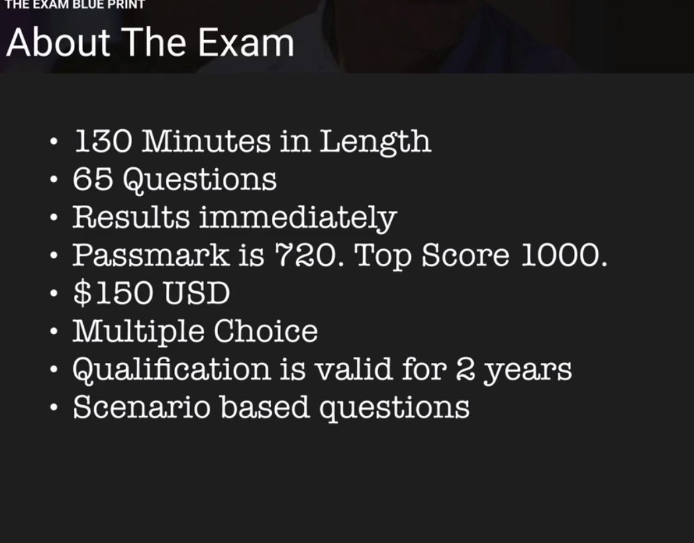

**IAM – IDENTITY ACCESS MANAGEMENT**

**IAM is to manage the users , roles and permission through AWS console**

**IAM gives**

1. **Centralized control of AWS account**
2. **Shared access to AWS account**
3. **Granular permissions**
4. **Identity Federation (including AD, FB LinkedIn) which means it enables to authenticate the users within the AD or facebook or LinkedIn etc**
5. **Multi-factor authentication if the company want to give access to the user only when multiple ways to authenticate into the account.**
6. **Provides temporary access to the resources. For example if the user need access to sql db for a while and then dynamodb after that**
7. **Allows for password rotation policy.**
8. **Integrates with many different AWS services. You will have many AWS services**
9. **Supports PCI DSS compliance.**

**Terms**

**Users – who are loggin into AWS account**

**Groups- Collection of users under one set of permissions. In order to do this create a group with set of permissions and assign the users to that group.**

Roles:

Policies: a **document that defines on or more permissions.**

**This is default view when using IAM for the first time. We normally not supposed to use the root account unless it is so needed. We create the IAM user and use that account to login.**

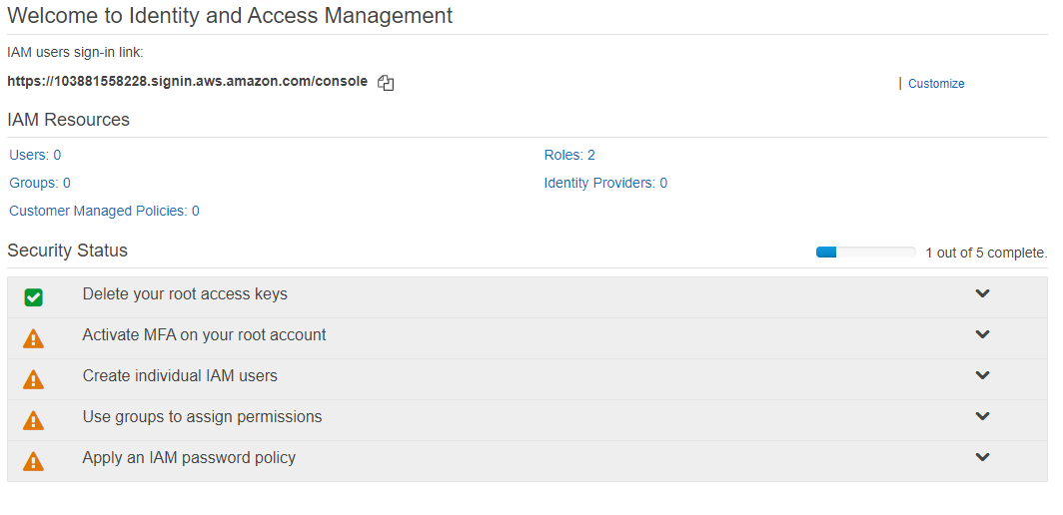

1. **Activate MFA on root account** 
   1. **You will have two options A virtual MFA device, U2F Security Key and A hardware MFA device**
   2. **For virtual device user need to have the MFA compatible device.**
2. **Adding users:**
   1. **For adding user there will be two access type options**
      * 1. **Programmatical access: After adding user , it will give Access key and Network secret key, The user need to have both to access the AWS programmatically. These credentials only show once for the first time. SO it is better to download as CSV file.**
      1. **Console access : It gives Alias name and password.**
3. **Role: Role can be created an assigned to instance. For example create a role with one or more permissions (Like S3 permissions) and assigned to an EC2 instance.**
4. **Policy: Policy is permission document which is in Json format. We can create our own new policy too.**

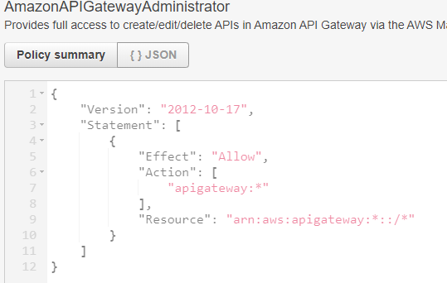

**EC2**

**EC2 Elastic Cloud computing is a webservice that provides to resize the computer capacity with in minutes. In olden days this task takes several days to finish as it needed to set the cables connect the new server etc.**

**This enables that you only pay for the capacity what you use for. And also it provides the developers not to worry about the common network or server failures scenarios.**

**EC2 options**

1. **On Demand: You pay per hour or by second and there no commitment required depending on the instance. For example as of now windows need per hour pay and linux server need per second pay. This may change .**

**This is perfect for the users whose applications are spiky, flexible loads and even at the time of development.**

1. **Reserved : Provides an option to reserve the capacity with the commitment with hug discount over the OnDemand option. The contracts usually be 1 to 3 year contracts.**

**Perfect for stable and predictable usage applications. If you pay upfront there will be great discounts.**

**Standard Reserved instances will have upto 74% off On demand.**

**Convertible RI s will have 54% off discount. For example if you want to go CPU intensive RI to Memory intensive RI.**

**Scheduled RIS : If you see a predictable usage in a day or month , you can schedule the RI to have that time to be peak. This option allows to match your capacity reservation to a predictable recurring schedule.**

1. **Spot**: This is you can bid for the price. Spot prices will vary time time. But the users need to be flexible with start and end times.
2. **Dedicated Hosts** : Dedicated hosts are physical EC2 servers where you can bring your software licenses to AWS and use them. Examples are VMWARE servers, Oracle servers and SQl servers etc.

**Useful for regulatory requirements that may not support multi tenant virtualization**.

**You don’t remember all these options for this exam may be just the family names should be good memorize**

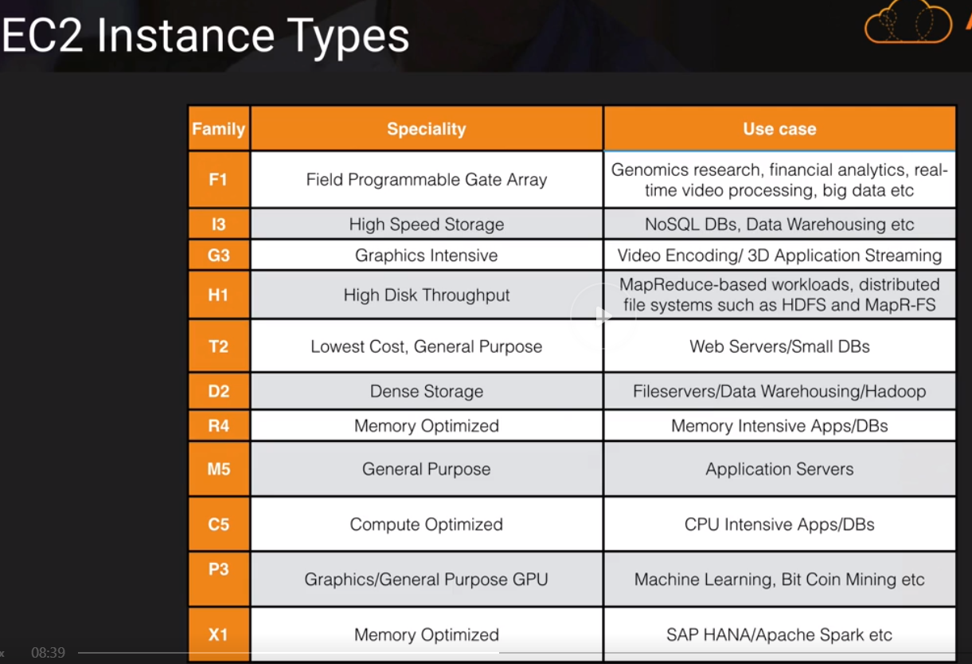

**FIGHT DR MC PX**

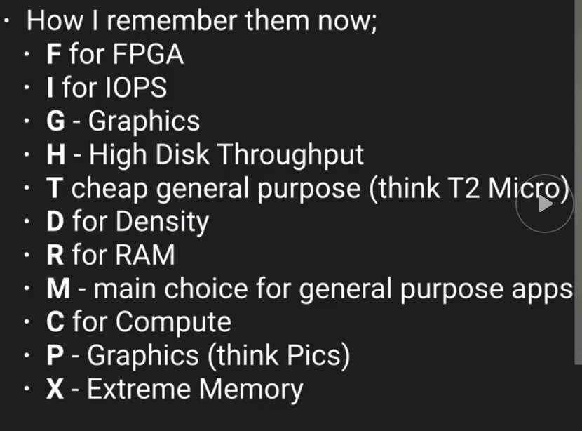

**EBS (Elastic Block Storage)**

**EC2 is virtual instance and EBS is virtual disk in the cloud. EBS allows to create a virtual disk and attach to EC2 instance. Once it is attached we can run database , file systems or application on top of it. EBS volumes placed in a specific availability zone to prevent single point of failure. So it is not just exist in one physical disk rather it is spread out availability zone.**

**EBS volume types**

1. **General Purpose SSD / GP2 : balanced b/w price and performance.**
   1. **It well suits for ratio of 3 IOPS (Input Output Per Second) per GB with up to 10000 IOPS and the ability to burst upto 3000 IOPS for extended period of time for volumes at 3334 GB and above.**
2. **Provisioned IOPS SSD / 101:** 
   1. **Suits for high intensive applications such as large relational or NOSQL Databases.**
   2. **Use if you need more than 10000 IOPS.**
   3. **Can provision upto 20000 IOPS**
3. **Throughput Optimized HDD / ST1 :** 
   1. **For Big Data/ Data warehouses / log processing**
   2. **Can not be a boot volume.**
      1. **Boot volume mean the portion of the hard drive that contains the operating systems. So in this case ST1 can be additional drive on the server just like we have D , E drives in the windows servers.**
4. **Cold HDD / SC1**
   1. **Lowest cost storage for infrequently accessed workloads. Typically use for file systems.**
   2. **Can not be a boot volume either.**
5. **Magnetic EBS**
   1. **Lowest cost per GB of all EBS volume types that is bootable.**
   2. **This EBS type is ideal for where data is accessed infrequently and where the lowest storage cost is important. Best example where you need a database for development and testing environments**

**Exam Tips:**

**HDD EBS storage volumes can not be boot volumes.**

**If the spot instance is terminated by Amazon EC2 you will not be charged for partial hour. But if you terminate the instance you need to pay for the full hour.**

**EC2 LAB**

**\*the cutting edge technologies will be available in Virginia region.**

**Launching web server.**

**You can create any of the Amazon Machine Images such as Linux, windows redhat, SUSE, Ubuntu etc**

**You can have build a webserver from AWS market place (?)**

**You can build webserver from Community AMIs such as Barracuda, F5. These web servers have default server settings that you can use.**

**VPC: Virtual private Cloud. You can create your own VPC to select IP range, create own subnets. Configure route tables etc**

**Tenancy : Possession of being tenant**

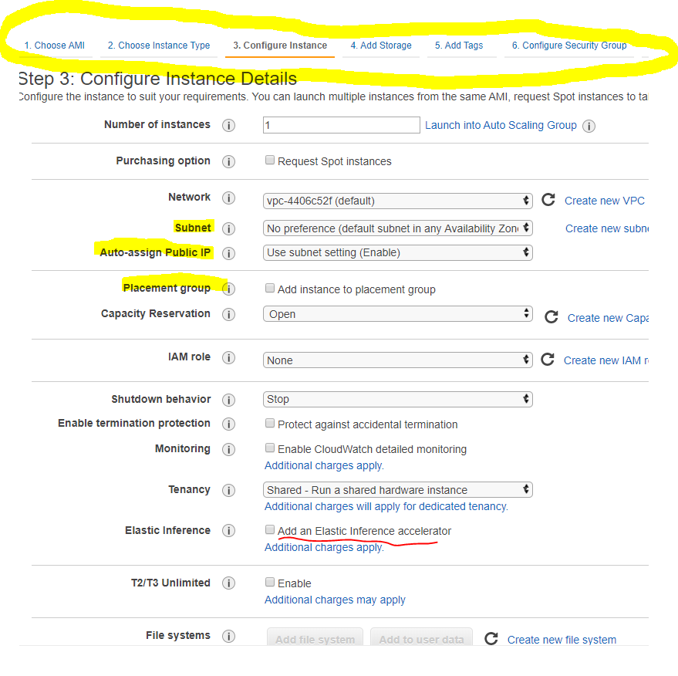

**Configure security group Tab: Here you can give permission who can access the web server. So security group in AWS is a set of firewall rules that control the traffic for your instance**

**\* DMZ or demilitarized zone (sometimes referred to as a perimeter network or screened subnet) is a physical or logical subnetwork that contains and exposes an organization's external-facing services to an untrusted network, usually a larger network such as the Internet. The purpose of a DMZ is to add an additional layer of security to an organization's local area network**

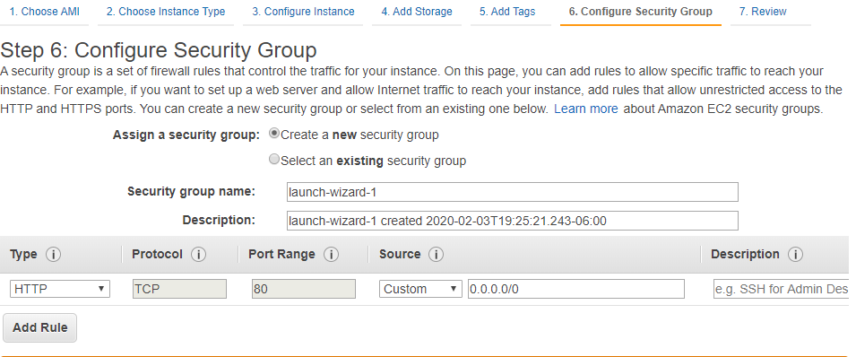

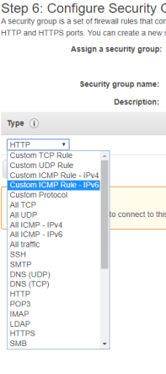 **Need to know all these types**

**SSH is the protocol to connect to Linux**

**RDP is for Windows :**

**These are the protocols to just connect remotely and access the EC 2 instance.**

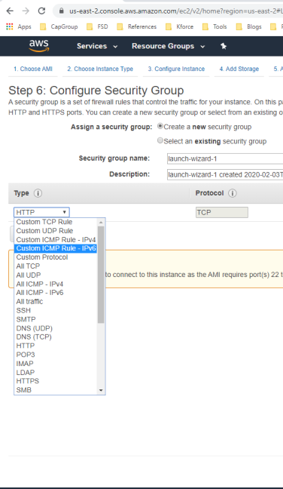

**In this example we can remote desktop into this instance using 22 port. And the web traffic comes from 80 port.**

**We mentioned source to Anywhere (this is not secure)**

**0.0.0.0/0 for Ipv4 and ::/0 is for Ipv6 (????) cider notation**

**This I basicall y saying connect any one using SSH notation**

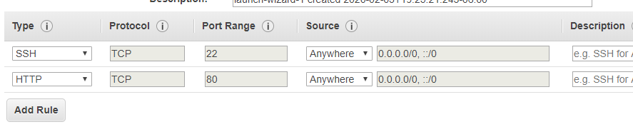

**Then Review and launch**

**It asks to download the public and private key file with extension .pem .**

**Run the EC2 instance from MAC**

**Go to Terminal**

**Cd <the location where you downloaded the public and private key>**

**Chmod 400 MyKeypair.Pem (This will change the permissions and lock down the file)**

**Ssh ec2-user@<ip address of the ec2 server> - i <keyname.pem> (This is to connect to EC 2 server through SSH) . and add the computer to the list of known hosts**

**Sudo su (this change to run the programs as another user in this case su (super user) which means you are logged in as super user in the EC 2 server)**

**Yum -update -y (**Yellowdog Update, Modified**(YUM) is a program that manages installation, updates and removal for**[**Red Hat package manager**](https://www.bing.com/search?q=RPM+Package+Manager&filters=sid%3a6a8c1e1a-bf60-2387-900d-349f7cf9dbbf&form=ENTLNK)**(RPM) systems. YUM allows the user to update groups of machines without having to update each RPM separately.) with this command it updates the sever with all the latest packages**

**Yum install httpd -y (this install apache in the server, Apache turns the EC 2 server into webserver)**

**Service httpd start (this starts the apache server)**

**Chkconfig httpd on (this is the configuration setting that we are doing. In case ec2 server starts , this little configuration will let the apache to run automatically rather we start again manually)**

**Service httpd status**

**Creating web page from terminal**

**Cd /var/www/html**

**ls (check the directory)**

**nano index.html (creates the file)**

**Elastic Load Balancer EBL**

**To balance the load between the web servers. If one webserver is overwhelmed ,**

**Three types of load balancers**

**Application load balancer**

1. **Work at OSI layer 7**
2. **Best suited for *HTTP* and *HTTPS* traffic**
3. **You can do advance request routing, sending specific requests to specific web servers. For example, if you need to request the sales.domain.com., we can do it to go to sales web server.**
4. **Model x**

**Network load balancer**

* 1. **Best suits for load balancing of *TCP* traffic where extreme performance is required.**
  2. **Operates at layer 4.**
  3. **Most expensive and high performant**
  4. **Network load balance is capable of handling millions of requests per second.**

**Classis load balancer \***

1. **Classic load balances are the legacy elastic load balancer. Even though Amazon is not pushing these loadbalncers, exam mainly focus on this.**
2. **Use to load balance *HTTP / HTTPS* applications and use layer 7 specific features, such as X-forwarded and sticky sessions.**
3. **Also use strict layer 4 load balancing for applications that rely purely on the *TCP* protocol**

**Load Balance erros**

**If there is an error 504 error code, it means there is an issue with application layer or database layer. Which means this is nothing to do with load balancer.**

**Some important points**

**The**X-Forwarded-For**(XFF) header is a de-facto standard header for identifying the originating IP address of a client connecting to a web server through an HTTP proxy or a load balancer. When traffic is intercepted between clients and servers, server access logs contain the IP address of the proxy or load balancer only. To see the original IP address of the client, the X-Forwarded-For request header is used.**

***TCP vs HTTP***

**TCP provides the delivery of a stream of bytes from a program from one computer to another computer.**

<http://www.differencebetween.net/technology/internet/difference-between-tcp-and-http/>

**OSI model is not a physical function or it doesn’t perform any functions. It is a conceptual framework to understand the complex interactions that are happening.**

**Layers 1-4 are considered the lower layers, and mostly concern themselves with moving data around. Layers 5-7, called the the upper layers, contain application-level data**

**A priest saw two nuns doing pushups**

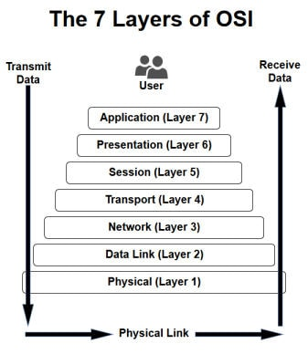

**Route 53**

**Route 53 is Amazon Domain Name service**

**It maps the domain name for**

1. **EC2 instances**
2. **Load balancers**
3. **S3 Storage / Buckets**

**Under the services 🡪 Network 🡪 Route 53**

**If you don’t have registered domains to create hosted zone, create one domain.**

**Mine is alienbot.net**

**Once we register domain name AWS created hosted zone for us.**

**We need to create ‘A record’ for the hosted zone. Typically that would be a load balancer.**

**A record : An**A record**maps a domain name to the IP address (Version 4) of the computer hosting the domain. An A record is used to find the IP address of a computer connected to the internet from a name. The format is 32 bit.**

**AAAA record : This is A record but for Ipv6 protocol . The format is 128 bit**

**To create load balancer EC2 🡪 Load Balancer. While creating load balancer , we need to register the *target group* to the instances that we need to map to.**

**Target type could be instance or IP or lambda function**

**Target Group : Load balancer routes requests to the targets in this target group using the protocol and port that you specify and perform health check on the targets using these health check setting. Each target group can be associated with only one load balancer.**

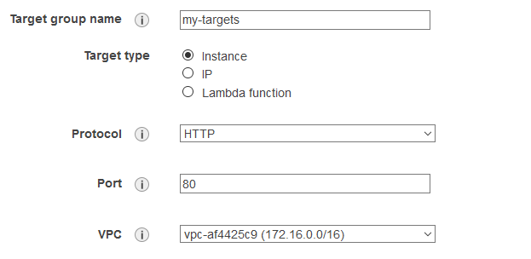

**CLI DEMO Command Line interface**

**To access any service from CLI type aws <service name> ls**

**Here aws s3 ls**

**To create a bucket**

**Aws mb s3://personalbucket**

**Here mb is make bucket**

**Echo test text > test.txt**

**Aws s3 cp test.txt s3://personalbucket**

**Cp – copy this command copies test.txt to s3 bucket that specified**

**There are many commands to use with CLI. Check the documentation but we don’t need to remember those commands for the exam.**

**EC2 with Role**

**When you create a role to an EC2 instance for specific service (for example for S3) EC2 will talk to S3 with that role instead of using the specific user.**

**SO Roles allow you to not use access key ID s and secret access keys.. Roles always preferred for secured access over using individual users. You can change a policy on a role and it effects immediately on all the instances. You can attach and detach roles to runnind EC2 instances, you don’t need to stop and start instances. For exam if you have question about roles and accesskey ids always choose roles.**

**How to Encrypt an EBS Volume**

**When creating EBS volume, if you attach encrypted snapshot volume it will be encrypted, if you attach an unencrypted volume it will be unencrypted. If you are creating new volume you have an option to Encrypt the Volume. This can be a question in exam.**

**EBS volumes should be created in the same availability zone that EC@ instance is created.**

**Create EBS volume with encryption enabled**

**SSH into server**

**lsblk – list all the drives on the server.**

**The one drive with / is the root drive**

**file -s /dev/xvdf -- to check if there are any file systems already exists**

**mkfs -t ext4 /dev/xvdf -- to make file system(mkfs) of type (-t) ext4 on /dev/xvdf**

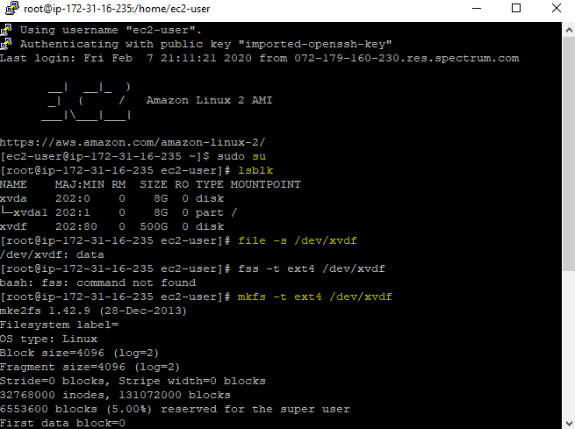

**we haven’t mounted the file system yet. To mount this**

**cd / -- go to root directory (which means where the OS is installed)**

**mkdir alienbotfilesystem -- make a directory in the root directory**

**mount /dev/xvdf alienbotfilesystem -- now mount the EBS volume**

**After this we unmount the EBS volume , detach the volume from console, create a snapshot of the volume , Delete the volume. Then create volume from the snapshot**

**umount -d /dev/xvdf -- to unmount the EBS volume from the root directory.**

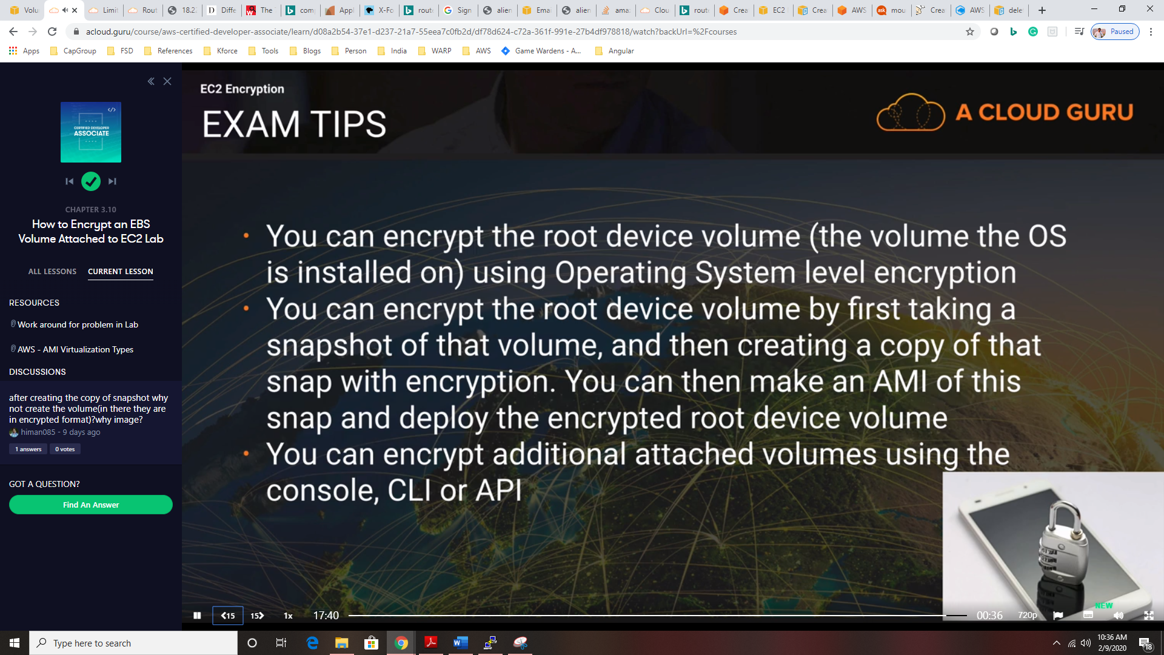

**File system Types – No need for exam just for information**

* auto - this is a special one. It will try to guess the fs type when you use this.
* ext4 - this is probably the most common Linux fs type of the last few years
* ext3 - this is the most common Linux fs type from a couple years back
* ntfs - this is the most common Windows fs type or larger external hard drives
* vfat - this is the most common fs type used for smaller external hard drives
* exfat - is also a file system option commonly found on USB flash drives and other external drives

**RDS**

**Relational Databases that AWS provides**

1. **SQL**
2. **MySQL**
3. **Oracle**
4. **PostgreSQL**
5. **Amazon Aurora : this amazon own database that similar to MySQL Amazon Aurora don’t have free tier template like others. (This could be exam question)**
6. **MariaDB**

**DataWarehousing**

**Use Datawarehouse to pull in very large and complex datasets and run queries against it to create reports. Examples CosmoDB, JasperSoft, SSRS, Oracle Hyperian etc.**

**OLTP vs OLAP  
OLTP : Online Transaction Process is just adding minimal information when a transaction occurs like order is placed.**

**OLAP : Online Analytical Process have much more data than OLTP. We user DWH for this purposes. DWH have different architecture and infrastructure pattern than regular Databases..**

**RedShift**

**ElasticCache**

**Elastic chache is a web service that makes it easy to deploy operate and scale an in-memory cache in the cloud. The service improve performance of web application by not pulling data from production databases but cache.**

**Elasctic cahe supports two open source Caching engines**

* **MemCached**
* **Redis**

**Creating RDS**

**After creating RDS amazon gives us the DNS name of the database. It will look like this**

**Endpoint**

**alienbotdb.cl2heusaibwc.us-east-2.rds.amazonaws.com**

**Port**

**3306**

**The exam tip is \*\***

**If EC2 instance is in one security group and RDS is in another security group, it can not communicate with each other it gives ‘unable to connect to RDS’. To resolve this we need open up the rds security group and open up the inbound rules and add the webserver security group to allow to connect on the RDS port. (3306)**

**Multi AZs and Read Replicas (Very important)**

**There are 2 different types of backups**

1. **Automated backups: Allow you to recovers the database to any point in time within a retention period. The retention period can be anywhere from 1 day to 35 days. These backups will take full daily snapshot and also store transaction logs.** 
   1. **AWS gives the backup database size same as the database instance. Thee backup data is stored in S3**
   2. **When back ups are taken within a defined window storage I/o may be suspended. So latency is expected**
2. **Snap Shots : this is manual backup. They are stored even after you delete the original RDS instance, unlike automated backups.**

**Restoring backups: When you do the restore, the new restored version of the database will be new RDS.**

**Multi AZ**

**The RDS instance have a replica RDS in US-EAST-1B ..in case of failover the amazon automatically updates the database DNS to the new one.**

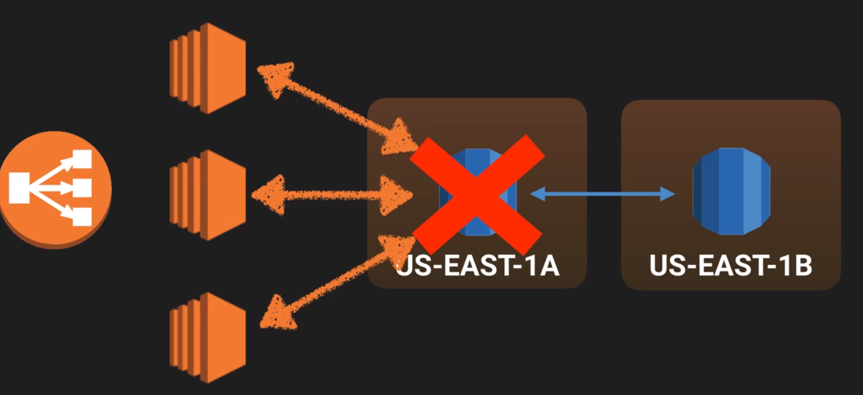

**Multi AZ allows you to have an exact copy of production db in another Availability zone. AWS handles the replication, so when the prod DB is written to, this write will automatically synchronized to the stand by database.**

**\*\*\* Important for Exam :Multi AZ is for Disaster recover only. It is primarily used for improving performance. IF we need performance we need Read Replicas. All the RDS (sql , oracle , my sql) provides multi AZ s. Amazon aurora has it by default.**

**Read Replicas : Read replicas allows you to have a read only copy of the prod DB. This is achieved by using Asynchronous replication from the primary RDS instance to the read replicas. These are basically designed for read only traffic. Like for reporting. These are allowed only for MySQL, Postgresql, MariaDB and Aurora. Not allowed for SQL and Oracle.**

1. **Must have automatic backups turned in order to deploy a read replica.**
2. **You can have up to 5 read replicas. You can have read replica of a read replica but watch out for latency.**
3. **Each read replica have its own DNS point.**
4. **You can have read replicas that have multi AZ or complete in another region. You can have the read replica in a second region.**
5. **Read replicas can be promoted to be their own database and this breaks the replication. For instance, if you have more than enough read replicas and you don’t need all of them. So you can have a read replica to have its own database and can do the work on it.**

**Elastic Cache**

**Elastic cache is a web service that makes it easy to deploy . operate and scale an in-memory cache in the cloud.**

**Types of ElasticCache**

1. **MemCacheD : A widely adopted memory object caching system. ElasticCache is compliant protocol with MemCached.**
2. **Redis** : **A popular open source in memory Key- Value store that supports data structures such as sorted sets and lists. ElasticCache supports Master/Slave replication and Multi-AZ which can be used to achieve cross AZ redundancy,**
   1. **SO if you want multi AZ redundancy, use Redis cache and if you don’t need multi-AZ use MemCached**

**Although both caches appear similar (as they are both in memory key stores) but they are different in practical. Because of the replication and persistent features of Redis, ElasticCache manages Redis more as a relational DB. Redis Elastic cache clusters are managed as stateful entities that include failover similar to Amazon RDS.**

**MemCached Use cases**

* **Object caching**
* **Simple caching**
* **If require multi threaded performance with multiple cores**
* **When you want the ability to scale cache horizontally**

**RedisCache use cases**

* **Supports advanced datatypes like lists, hashes and sets**
* **Sorting and ranking in memory such as leaderboards**
* **If you want persistence as a key aspect**
* **Multi AZ environments**

**S3**

**S3 is purely object storage such as file and images. Not for operating systems. The data is spread across multiple devices and facilities.**

**Files in S3 can be from 0 bytes to 5 TB. And the storage is unlimited**

**S3 is a universal namespace and it should be unique globally. Even it should be unique if it is in another region or zone. For ex:** [**https://S3-eu-west-1b.amazonaws.com/alienbotbucket**](https://S3-eu-west-1b.amazonaws.com/alienbotbucket)**.**

**When you upload the file (This is called PUT) of new object it is immediately available for read or retrieve**

**When you overwrite PTS and DELETES , it needs some time to propagate. This is called Eventual Consistency.**

**S3 is object based. Object consists of**

* + **Key**
  + **Value (the object data which is made up of bytes)**
  + **Version ID**
  + **Metadata**
  + **Subresources** 
    - **Bucket policies or Access control lists : These are used for accessing the objects in S3.**
    - **CORS (Cross Origin Resource sharing)**
    - **Transfer Acceleration : The faster to transfer files from one S3 to another S3**

**Types of S3**

**S3 : Availability – 99.99**

**Durability – 99.999999999 (11 X9 ) .**

**Stored across multiple devices and facilities**

**S3-IA( Infrequently Accessed) : If you need a S3 storage that is less frequently access but requires rapid access. Lower than S3 but amazon charges for retrieval.**

**S3 – OneZone IA : It is same as S3-IA but spawned in only one availability zone. SO if one facility is failed you need to wait for S3 to come back online. 20% lower than S3-IA. 99.99999999999 (11X9) durability but 99.5% availability**

**Reduced Redundancy storage: 99.99% availability and 99.99% durability. Useful for the data that can easily recreatable. (This is starting to disappear from AWS but still in the exam)**

**Glacier : It is very cheap. Use for archives. It takes 3-5 hours to restore**

**In 2018 Amazon introduced another type of S3 which is**

**S3-Intelligent Tiering**

**This has 2 tiers , one for frequent one for infrequent. This means when an object is not accessed for 30 days S3 automatically moves the object into infrequent tier.**

**This will be used for unpredictable and unknown object access pattern. SO this gives optimized cost. No fees for accessing your data but monthly fee for monitoring/ automation like $ 0.0025 per 1000 objects.**

**S3 charges for**

**Storage per GB**

**Requests (Get put copy)**

**Storage management policy : which means**

**Data management pricing : Data transfer out of S3**

**Transfer Acceleration : Use of CloudFront to optimize transfers.**

**Important to read aws s3 faqs at aws.amazon.com/S3/faqs**

**By default S3 buckets are PRIVATE . which means except the one who created the bucket can not access it.**

**Bucket policies : The security access policies you can configure per S3 bucket**

**Access Control lists : you can configure the access per object**

**S3 buckets can be configured to have logs that logs all the activity occurred to the S3 bucket. These logs will be written to another S3 bucket**

**Access control lists policies will be overwrite bucket policies.**

**ARN : Amazon Resource Name**

**You need to give the ARN s of the user and ARN of the bucket name when creating bucket policies.**

**S3 Encryption**

**At Transit (Encrypts the data in network)**

**SSL/TLS : Transfer Layer Service encryption. This is typically means when you upload an object and download object. HTTPS is the protocol we use to do TLS.**

**At Rest (Server Side Encryption)**

* + 1. **S3 Managed keys (SSE -S3 )**
    2. **AWS KMS (SSE -KMS) Additional feature is AWS gives another key to encrypt and it is called envelop**
    3. **Customer provide Keys (SSE-C)**

**Client side Encryption: In this customer take care of all the encryption before uploading file.**

**The below is the request header to be sent when uploading a file to S3.**

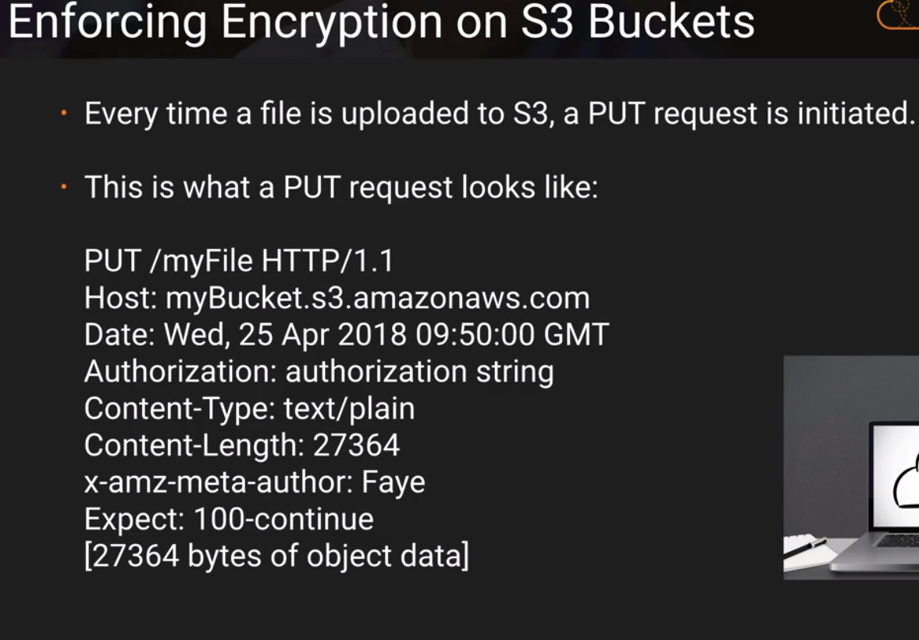

**If the file is to be encrypted we need to add another parameter to the request header which is**

**x-amz-server-side-encryption-parameter.**

**Two options for this parameters that are currently available are**

**x-amz-server-side-encryption:AES256**

**x-amz-server-side-encryption:ams:kms**

**And then we can configure the bucket policy to deny any PUT request that doesn’t have the x-amz-server-side-encryption parameter in the request header**

**CORS Configuration**

**Cross Origin Resource Sharing**

**S3 bucket 🡪 properties 🡪 Static website hosting (This is to make the S3 storage as a website hosting)**

**To configure CORS**

**S3 bucket 🡪 Permissions🡪 CORS configuration then give the url of the S3 bucket to have cors allowed to that website.**

**The use case for CORS in S3 when you have images in one S3 bucket, Javascript files in one bucket, Html files in one bucket you can set up CORS to interact with each other.**

**CLOUD FRONT**

**What is CDN Content Delivery Network**

**A CDN is a system of distributer servers that deliver webpages and other web content to a user based on the geographic locations of the user, the origin of the webpage and a content deliver server.**

**CloudFront to deliver the content to the user from edge location. First time when web servers gives the content it will be cached in the edge location based on the user location and when the user requests the same object next time it will be delivered from the edge location cache.**

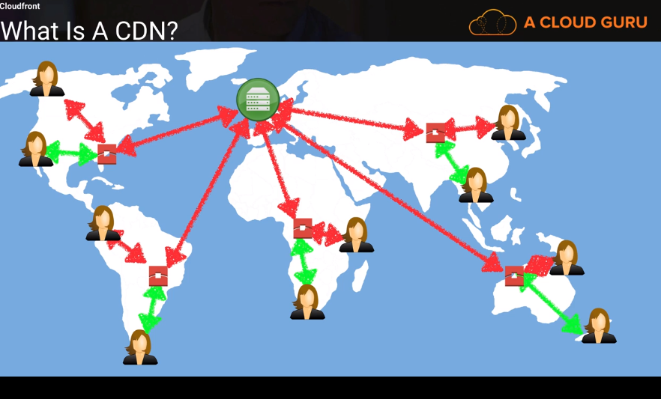

**Cache has time to live. You can manually clear the cache but Amazon charge for this action.**

**\*Edge location: This is the location where contente is cached and can also be written. Separate to an AWS region or AZ. You can also write the content edge location. Amazon have more edge locations than the Availability Zones**

**Origin : Origin of all the files that the CDN will distribute. Origin can be an S3 bucket, an EC2 instance, an Elastic load balancer or Route 53**

**Distribution : thi is the name given the CDN, which consist of Edge locations.**

**Two types of distribution**

1. **Web Distribution : This is typically used for web sites HTTP, HTTPS.**
2. **RTMP : used for media streaming. Real time message protocol**

**So Amazon cloud front can be used to deliver your entire web site including dynamic, static, straming and interactive content using a global network of edge locations. Requests for your content are automatically routed to the nearest edge locations , so content is delivered with the best possible performance**

**CloudFront also can be used to enable Transfer Acceleration (Upload files into S3) fast easy and secure transfers of files over long distances between your end users and S3 bucket.**

**Transfer Acceleration takes advantage of CloudFront as the data arrives at an edge location, data is routed to S3 over an optimized network path.**

**Cloud Front Lab**

**Click on create cloudfront the options are.**

**Origin Name : you can have S3 , load balancer, EC2 instance or your physical server on premises(give the IP address).**

**Access Identity : You need to create an identity that cloud front can use to read and forward the content**

**Cache TTL : Minimum is 0 seconds , Maximum is 31 million seconds (365 days) , default is 86000 seconds(24 hours) TTL : Time to live**

**\*Restricted viewer access (Use signed URL or Signed Cookies) : yes or no**

**If you want to restrict users to restrict viewing the content in S3 like an image by going to the url in browser.**

**AWS WAF Web ACL**: **This use to traffic filtering or any hacking like sql injection, cross side scripting. If you want to use AWS WAF to allow or block requests based on criteria that you specify, choose the web ACL to associate with this distribution. This is protect at application layer (not network layer)**

**SSL Certificate: Two options**

1. **Default certification that AWS provides**
2. **Use your custom SSL certificate . You have to store it in AWS certification manager**

**Creating distribution take 15 to 20 minutes because it needs to provision the configuration to all of its Geolocations around the world. How many of them?**

**You can remove an object from cache using Invaldation Rule but this will be charged**

**T**here are three options in the question which can be used to secure access to files stored in S3 and therefore can be considered correct. Signed URLs and Signed Cookies are different ways to ensure that users attempting access to files in an S3 bucket can be authorised. One method generates URLs and the other generates special cookies but they both require the creation of an application and policy to generate and control these items. An Origin Access Identity on the other hand, is a virtual user identity that is used to give the CloudFront distribution permission to fetch a private object from an S3 bucket. Public S3 buckets should never be used unless you are using the bucket to host a public website and therefore this is an incorrect option. Further information:

**SERVERLESS**

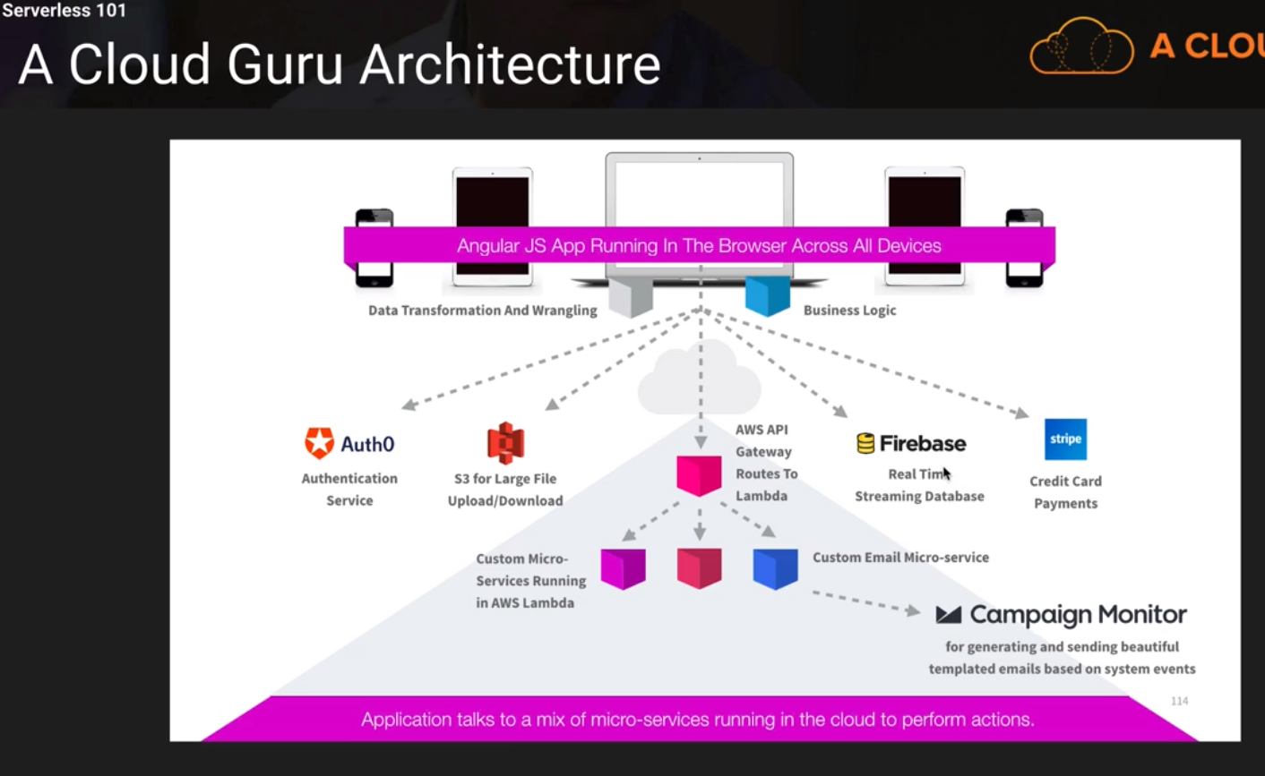

**Serverless History**

**DataCenter 🡪 IAAS 🡪 PAAS 🡪 Containers 🡪 Serverless.**

**Lambda is born thus it computes all your server layer architecture and scaling etc. All you need to worry about your code.**

|  |
| --- |
| **Datacenters,Hardware,Assembly coding, Operating systems, Application layer/ AWS API calls, Highlevel languages** |



|  |
| --- |
| **AWS LAMBDA** |

**AWS lambda is a compute service where you can upload your code and create a lambda finction. AWS lambda takes care of provisioning and managing the servers that you user to run the code. You o=don’t have to worry about OS. Patching, Scaling etc.**

**The ways you can use Lambda are**

1. **As an even driven compute service where AWS lambda runs your code in response to events. These events could be changes to data in S3 or an dynamo db table.**
2. **As a compute service to run yoour code in response to HTTP requests using API gatewway or API calles made using AWS SDK s**

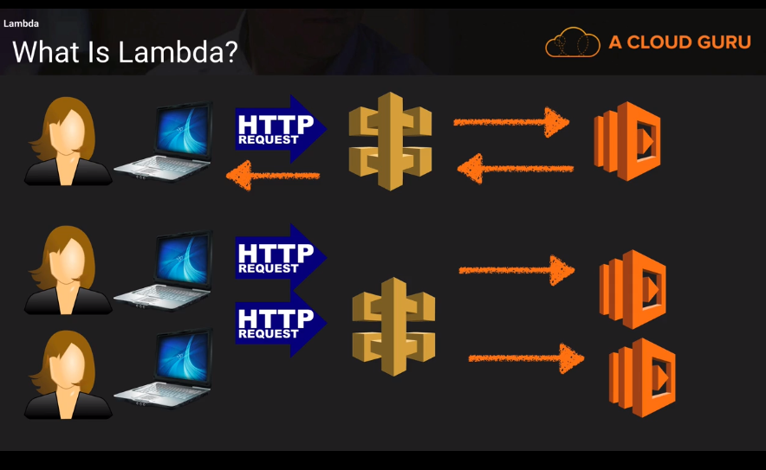

**The languages that supports Lambda is**

**Node.js Java Python C# GO**

**Lambda price**

1. **Number of requests** 
   1. **First million requests are free. 20 cents per 1 million requests there after**
2. **Duration** 
   1. **Duration is calculated from the time your code begins executing until it return or otherwise terminates, rounded up to the nearest 100 ms. The price depends on the amount of memory you allocate to your function. You are charged 0.00001667 for every GB-second used.**

**Exam tips.**

**Lambda scales out (not up) automatically**

**Lambda is serverless. Services like API gateway, s3 , RDS , Lambda is serverless. EC2 is not a serverless because you need a phusical server.**

**Lambda functions are independent 1 event triggers 1 function. And 1 Lambda function can trigger other functions.**

**Architectures can get extremely complicated, AWS X-ray allows you to debug what is happening.**

**Know your triggers. Google it or check the option in the lambda functio in AWS console.**

**API gateway**

**AWS IoT**

**Alexa skill set**

**Application load balancer**

**Cloudwatch events**

**Cloudwatch Logs**

|  |  |
| --- | --- |
| **API gateway**  **AWS IoT**  **Alexa skill set**  **Application load balancer**  **Cloudwatch events**  **Cloudwatch Logs**  **Code Commit**  **Cognito Sync trigger** | **Dynamo DB**  **Kinesis**  **S3**  **SNS**  **SQS**  **And other partner event sources** |

**API GATEWAY**

**Amazon API gateway is fully manages service that makes it easy for developers to publish, maintain, monitor and secure API s at any scale. With a few clicks in AWS console you can create an API that acts as a front doot for applications to access data, business logic or functionality from your back- end services such as application running on EC2, code running on Lambda or any web application.**

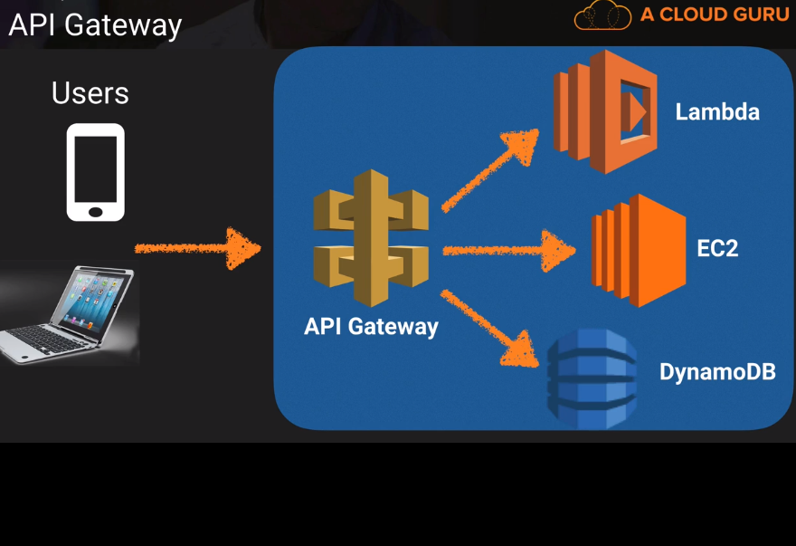

**API caching**

**You can enable API caching in Amazon API gateway to cache end point response. With caching we can reduce the number of calls m ade toyour end point and also inprove the latency of the request to the API.When enable API gateway caches respnses from the end point for a specific TTL (time to live)period in seconds.**

**Same Origin Policy vs CORS\*\***

**What is HTTP Options?**

**LAMBDA Versioning**

**Each lambda function version has a unique ARN (Amazon Resource Name). After your publich a version it is immutable. Only the latest version can be changeable.**

**AWS lambda maintains your latest function code in $LATEST version. When you update your function code, AWS lambda replaces the co de in the $LATEST verson of the lambda function.**

**Qualified and Unqualified ARN**

**Qualified ARN : the function ARN with the version suffix.**

**Unqualified ARN is the function without version suffix.**

**Alias: alias is basically a name given to a version and it maps to the versions of all the lambda functions.**

**Exam Tips : Split traffic is important in the exam**

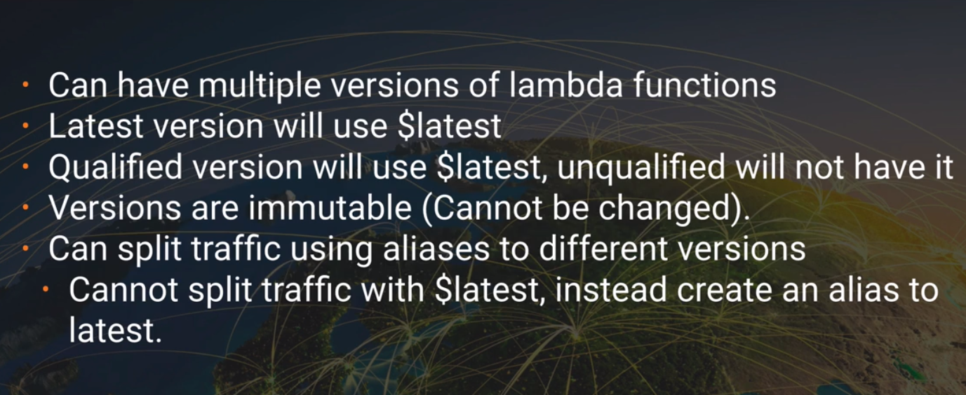

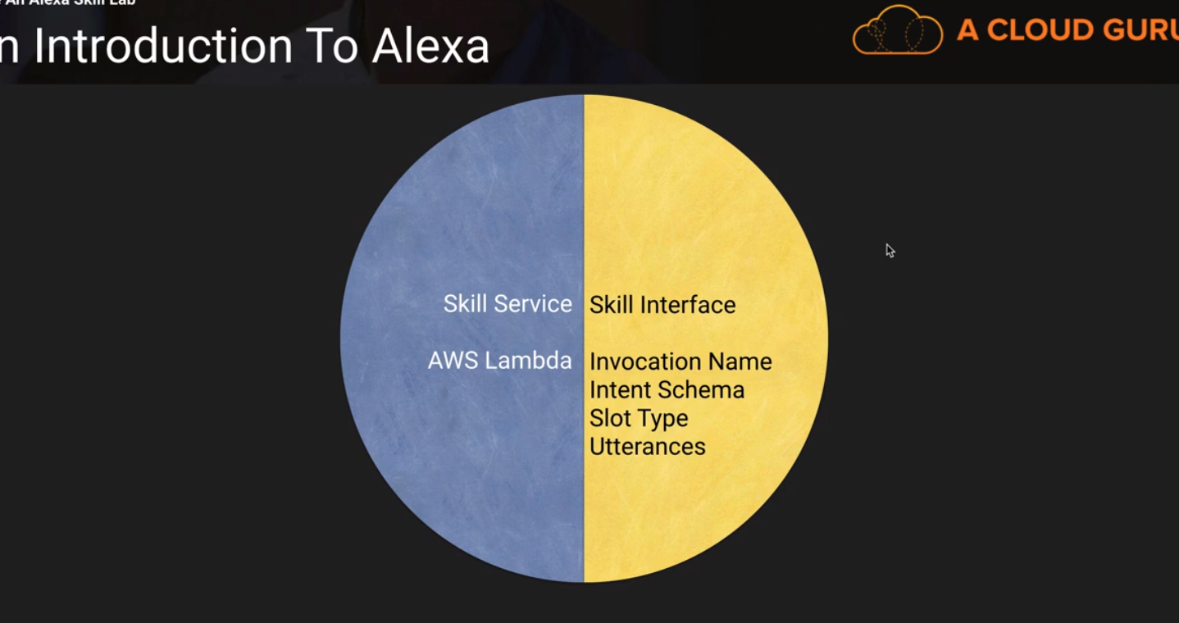

**STEP FUNCTIONS**

**Step functions provides graphical visualization and test serverless applications. It provides graphical console to arrange and visualize the components of your application as a series of steps. This makes simple to build and run multistep applications.**

**Step functions automatically triggers and tracks each step and retires where there are errors so application executes in order and as expected.**

**Step functions logs the state of each step so then the things go erong you can disgnose and debug problems quickly.**

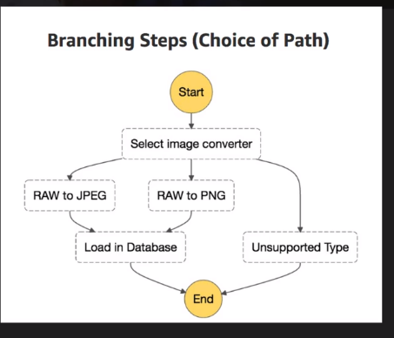

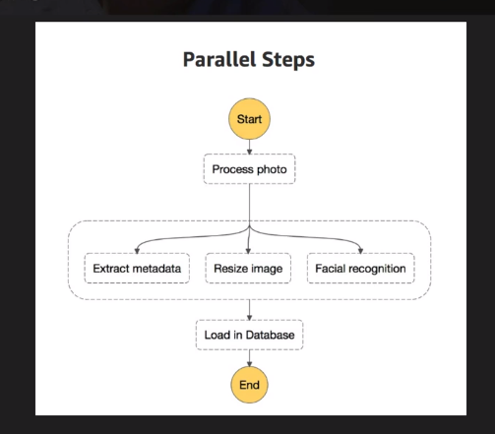

**For the exam you just need to know what are step functions.**

**They are under application and integration category**

**It uses JSON based amazon states language**

**X-RAY**

**Aws -Xray is a service that collects data about requests that your application serves and provides tools you can use to view, filter and gain insights into that data to identify issues and opportunities for optimization. For any traced request to the application you can see detailed information not only about the request and response but also about call that your application makes to downstream AWS resources micro services databases and HTTP web api s**

**X-Ray SDK is installed / stored in your application that sends JSON data to X-Ray Daemon via UDP. X-Ray Daemon sends it to X-Ray API . This create X-Ray console which tells the time takes for each resource.**

**We also have Scripts and tools to**

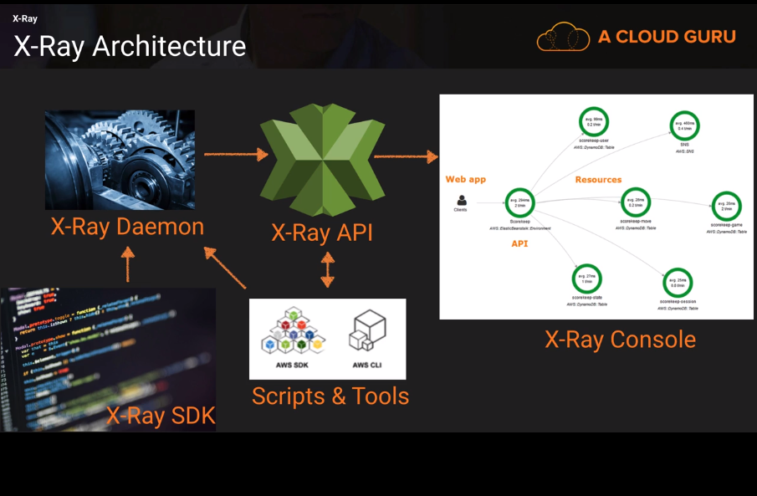

**X-Ray SDK provides**

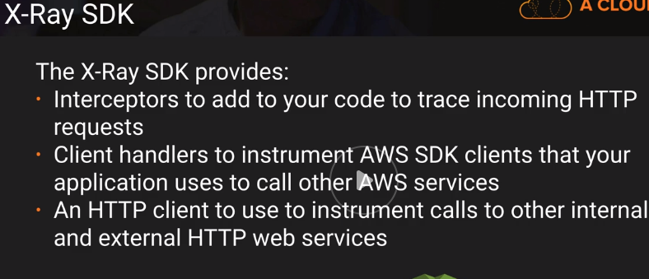

**X-Ray integrates with (NOT S3)**

1. **Elastic load balancing**
2. **AWS lambda**
3. **Amazon API gateway**
4. **Amazon Elastic compute cloud EC2**
5. **AWS Elastic Beanstalk**

**X Ray supports (Almost all the high level languages)**

**Java, GO , Node.JS ,Python ,Ruby, .Net**

<https://us-east-2.console.aws.amazon.com/elasticbeanstalk/home?region=us-east-2#/newApplication?applicationName=scorekeep&solutionStackName=Java>

**DYNAMO DB**

**Amazon dynamo db is fast and flexible NoSQl database service afor all applications with milli seconds latency at any scale. It is fully managed database and supports both document and key-value data models. It is also serverless.**

**Dynamo db is stored in SSD which is more performant.**

**Single DB is spread across 3 geographically distinct data centers to avoid single point of failure.**

**We have two Data consistency models**

1. **Eventual consistency Reads (This is default)**

**It takes a second after you update the data ()**

1. **Strongly consistent Reads**
   1. **All successful writes reflects the reads in all three locations**

**Schema**

**Tables**

**Items : rows**

**Attributes : Columns**

**Supports key-value and document data structures**

**Key = the name of the data , value = data**

**Document data structures can be written in JSON, HTML or XML.**

**Dynamo DB Primary keys: Dynamo db stores and retrieves data based on primary key**

**Two types of PK\***

**Partition key : Unique attribute – Value of partition key will be go through internal hash function and it outputs the partition ot physical location on which the data is stores.**

**If you are using partition key as your primary key then no two items can have the same partition key.**

**Composite key : combination of partition key and Sort key**

**In this case 2 items can have same partition key but not same sort key. All items with the same partition key will be stored together and sorted according to the sort key. This allows to store multiple items with same partition key.**

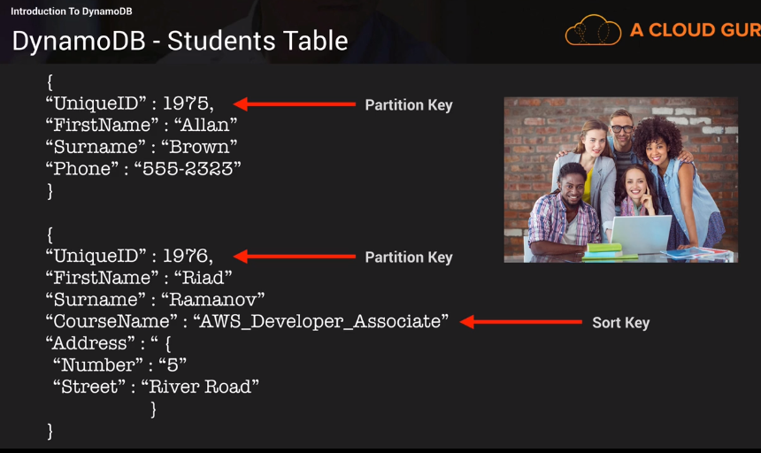

**DynamoDB access control**

**Authentication and access control is managed using AWS IAM. You can create an IAM user within AWS account which has specific permission to access and create tables. You ca create an IAM role which enables you to obtain temp access keys which can be used to access dynamodb**

**You can also use a special IAM Condition to restrict user access to only their own records.**

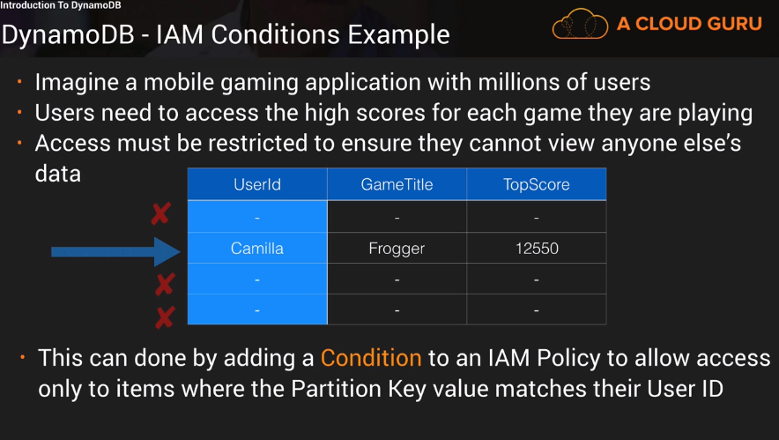

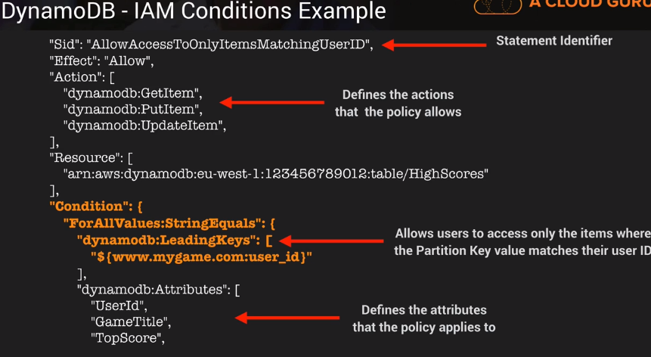

**Dynamodb:LeadingKeys is important for exam**

**Creating Dynamodb using python script**

**CHECK NOTES**

**INDEXES**

**In sql ddb an index is a datastructure which allows to perform fast queries on specific columns in a table. You select the columns that you want included in the index and run your searches on the index.**

**In dynamodb , there are 2 types of index.**

1. **Local Secondary Index**
   1. **You can only create this index only when you are creating table and can not modify or add or remove later after the table creation**
   2. **It has the same partition key as the original table but a different sort key.**
2. **Global Secondary Index**
   1. **These are much more flexible that Local.**
   2. **You can create this index when you create the table or can add later.**
   3. **Different partition key as well as a different sort key**

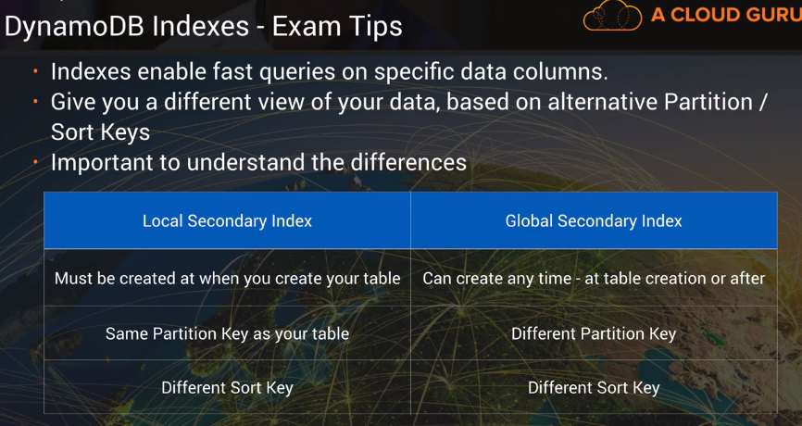

**SCAN Vs Query API Calls**

**Query : is to find data based on primarykey and a distinct value. You can use sort key to refine the results.**

**BY default a Query return all the attributes. If you need specific attributes you can use ProjectionExpression parameter. Remember this is as LINQ select projection**

**Results are sorted by sortkey by default.**

**If you want to reverse the order you can set the ScanIndexForward parameter to false. It only applies to Queries not Scans.**

**Query is by default Eventual consistent but you can set to Strongly consistent**

**Scan**

**It examines all the items in the table.**

**BY default a Scan return all the attributes. If you need specific attributes you can use ProjectionExpression parameter.**

**Of course Query is more efficient as Scan dumps the whole table and then we can add filters**

**You can improve the query performance by setting the page size. So smaller pages everytime to avoid throttling.**

**You can improve scan operation by running parallel scans. But avoid scans wherever it is possible.**

**DynamoDB throughput provision \*\*\***

**DynamoDB provisioned throughput measured in Capacity Units**

**1X Read capacity Unit = 1 X strongly consistent Read of 4 KB per second OR**

**2 X Eventually Consistent Read of 4 KB per second -- default**

**1 X Write capacity Unit = 1 X Write per 1 KB**

**Formulas**

**Strongly consisted Capacity = number of items * (size of one item in kb /4)**

**Eventually consisted Capacity = (number of items * (size of one item in kb /4))/2**

**Write capacity = number of items * (size of one item in kb /1)**

**size of one item in kb /4 rounded to the nearest 4**

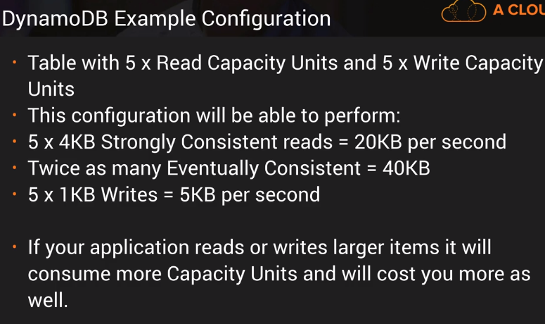

**Dynamo DB on Demand.**

**Here you don’t specify any capacity requirements. SO basically AWS scale up or down the DB capacity. This best suites when the read and write can not be predictable.**

**This is introduced in November 2018**

**DynamoDB Accelerator DAX**

**DAX is a fully managed clusted in-memory cache for DynamoDB. Delivers up to a 10X read performance for millions of requests per second. This is only for read. Ideal for Read Heave and burst workloads**

**DAX is a write through caching service. This means data is written to the cache as well as the back end store at the same time.**

**If the item is available in the cache (Cache hit), DAX returns the result to the application.**

**If the item is not available (Cache miss) then DAX performs an Eventually Consistent GetItem Operation against DynamoDB.**

**Retrieval of data from DAX reduces the read load on DynamoDB tables, and as well as it may reduce provisioned read capacity**

**This is not suitable for write intensive application because it only for read only applications.**

**ELASTICCACHE**

**This is in memory cache in the cloud that sits in front of RDS or DynamoDB.**

**Good if your application is read only and the data is not changing frequently.**

**Same as Elastic cache in RDS section Memcached and Redis Cache.**

**2 strategies**

**Lazy loading. Loads the data into the cache only when necessary.**

**If the data is not in the cache or it is expired, Elastic cache sends null. Then application need to fetch the data from the database and writes the data to Cache so next time will be available.**

**The disadcantage is the cache may have stale data. In order to over come we use TTL (Time to live). Specify number of seconds until the data expires to avoid keeping stale data in the cache.**

**Write-Through : adds or updates data to the cache whenever data is written to the database**

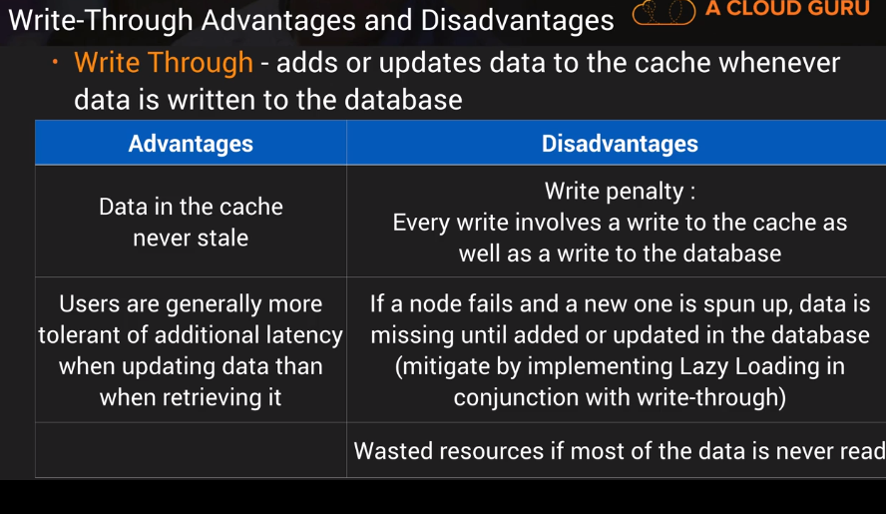

**DAX vs Elastic cache**

**DAX is only for dynamodb. And it is only write through caching, It does not support Lazy loading or write through caching strategies. So for DynamoDB use DAX and for RDS use ElasticCache.**

**DynamoDB Transactions**

**Check AWS documentation for this since Acloudguru have not many details on this.**

**This is for mission critical transactions like ‘all or nothing type transactions**

**ACID transactions**

**Atomic – Transaction treated as a single unit**

**Consistent – Must be valid transaction. Prevents any data integration issues**

**Isolated – Independent**

**Durable – once transaction is committed then it stays committed even if the system failure the data should be persistent.**

**For example financial transaction and your transaction should be all or nothing transactions. So you don’t want that transaction as a partially completed.**

**DynamoDB TTL**

**Time To Live**

**Expired items marked for deletion. Once an item is marked for deletion it will be deleted in 48 hours.**

**Great for removing irrelevant data or old data such as Session logs, event logs or temp data.**

**TTL expressed as epoch time. Number of seconds which elapsed after Jan 1st 1970 12 AM**

**You will find TTL option in Actions menu in the DynamoDB table**

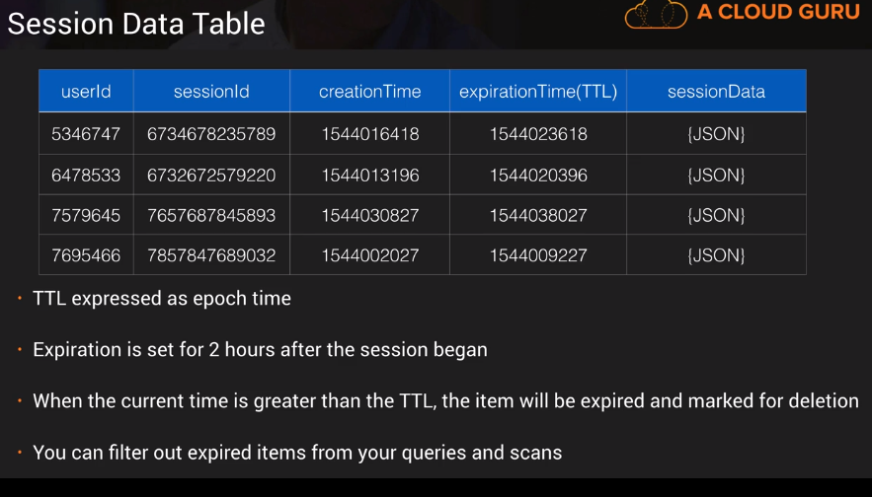

**DynamoDB Streams**

**Any item level modifications such as insert update delete into DynamoDB streams.**

**Logs are encrypted at rest and will be stored for 24 hours.**

**Basically used as trigger to lambda function that means if you have any change in the table item , we can trigger a lambda function for the change.**

**Dynamo DB streams can be accessed using a dedicated end point.**

**You can capture states before the change and after the change.This is really good for serverless architecture. Streams can be event source foe lambda functions.**

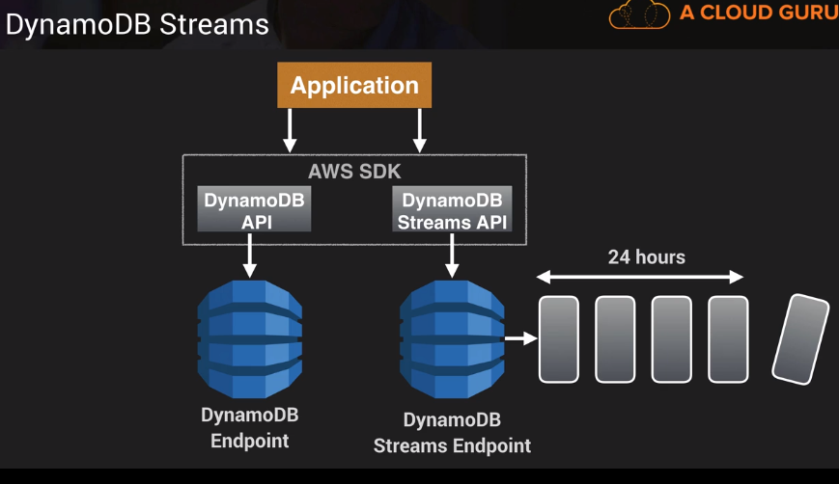

**Example use case is**

**When there is a change in order (which is recorded in dynamodb stream) you can trigger lambda functionto send notification which calls SNS which sends notification to SQS. Then the application can read the notification from SQS.**

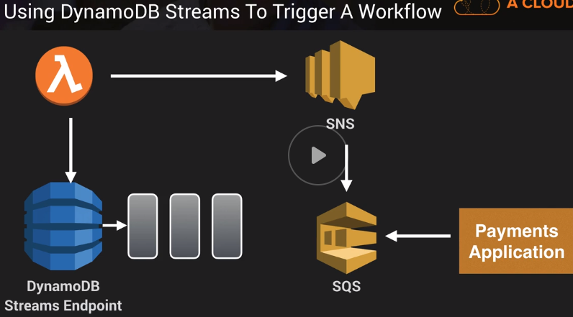

**Provisioned Throughput Exceeded Exception**

**ProvisionedThroughputExceededException : occurs when dynamodb makes requests exceeded than what you provisioned when creating table.**

**If you are using AWS SDK, AWS will retry until the read or write is successful.**

**If you are not using AWS SDK , you can**

1. **You can reduce the request frequency**
2. **Use Exponential BackOff:** 
   1. **Many components in a network generate errors during overload. That can be anything in network like Load balancer, switches, DN servers etc. To avoid this you can implement retries.**
   2. **In addition to simple retry AWS SDK use Exponential backoff.**
   3. **The requestor implements progressively longer waits between failed retries. For example if an event fails it retry in 50ms , if it fails it retries after 100 ms, if it fails then it retry after 200ms. This improves flow control**
   4. **If after 1 minute this doesn’t work, the request size may be exceeding throughput for read or write capacity. At this point you can investigate the issue. Then you can determine to increase capacity or use DAX etc,**
   5. **Exponential back off is not only for DynamoDB, every AWS SDK has this feature. Like S3 , CloudFormation, SES.**

**KMS**

**Key Management Service is a managed service that makes it easy for you to create and control the encryption keys used to encrypt your data. AWS KMS is integrated with other AWS service like EBS, S3, RedShift, Elastic Transcoder, Amazon workmail, RDS etc to make it simple to encrypt your data with encryption keys that you manage.**

**Symmetric vs Asymmetric keys**

**Key Material options KMS , external (your own key) or Customer keystore (CloudsHSM)**

**KMS is multi tenant solution**

**CloudHSM is dedicated hardware.**

**Encryption keys for KMS is Regional. That means if you have encryption key in one region and you can decrypt date in another region.**

**When creating encryption key (CMK – Customer Master Key), you will give users as administrators. These administrator can manage the key but can not use the key to encrypt or decrypt the data**

**After that you will provide the users to use the CMK that who can use the key.**

**CMK can never be exported.**

**KMS API Calls ** for exam**

**Launch Ec2 instance as same as where your KMS policy been created**

**Ssh into EC2**

**Create a text file in the instance**

**Aws configure for the user access key and secret accesskey**

**Then perform these actions where the YOURKEYIDHERE is the KMS policyID**

aws kms encrypt --key-id YOURKEYIDHERE --plaintext fileb://secret.txt --output text --query CiphertextBlob | base64 --decode > encryptedsecret.txt

aws kms decrypt --ciphertext-blob fileb://encryptedsecret.txt --output text --query Plaintext | base64 --decode > decryptedsecret.txt

The re-encrypt API call encrypts data on the server side with a new customer master key (CMK) without exposing the plaintext of the data on the client side.

aws kms re-encrypt --destination-key-id YOURKEYIDHERE --ciphertext-blob fileb://encryptedsecret.txt | base64 > newencryption.txt

* Enable key rotation for key rotation every year

aws kms enable-key-rotation --key-id YOURKEYIDHERE

**KMS Envelop Encryption**

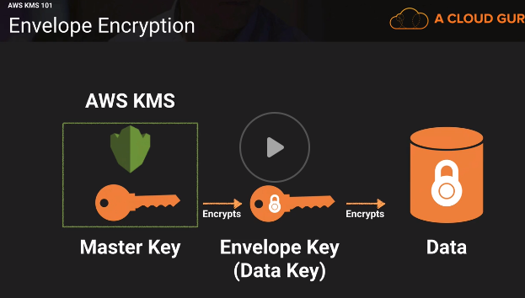

**AWS takes CMK and encrypts Envelop Key. And this envelop key is used to encrypt the Data**

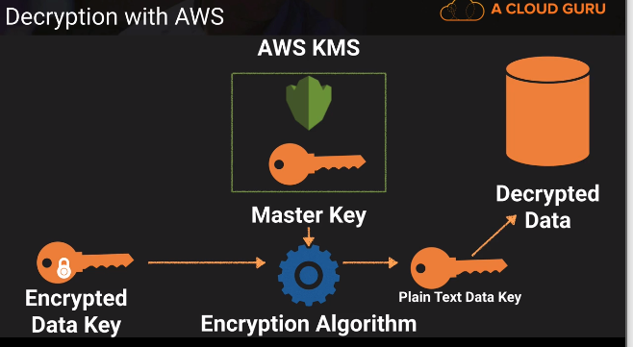

**Test fail**

The Customer Master Key is used to encrypt and decrypt the Data Key or Envelope Key. The Data Key or Envelope Key is used to encrypt and decrypt your files. AWS Managed Customer Master Keys cannot be used to **directly** encrypt and decrypt files, since permissions cannot be changed to them. Customer Managed Customer Master Keys can be used with the KMS command to encrypt the file, when Key Usage rights are given.

**AWS SERVICES**

**SQS\***

**This is the first public service was available**

**SQS is web service gives you access to a message queue that can be used to store messages while waiting for a computer to process them.**

**Amazon SQS is a distributed queue system that enable web service application to quickly and reliably queue messages that one component in the application generates to be consumed by another component. So A queue is a temp repo for messages that are awaiting processing.**

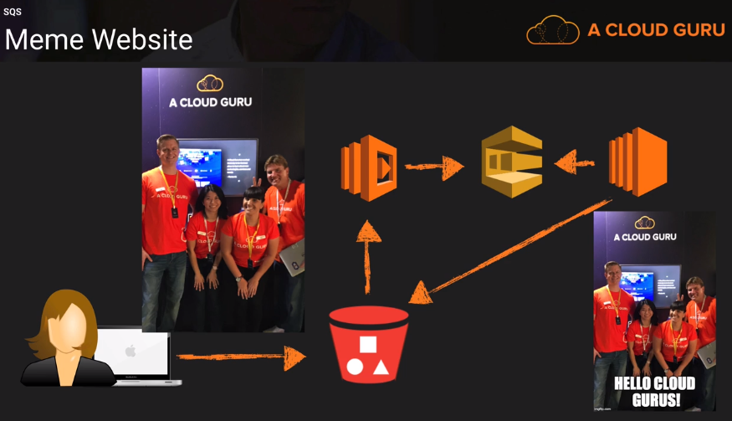

**You can have auto scaling sit behind the SQS to see how many messages sits in SQS**

**SQS is pull based system (other type of system is Push based system).\***

**Even the application server fails the SQS will have the messages in the process.**

**So with SQS you can decouple the components of an application so they can run independently. Any component of distributed application can store messages in the queue. Messages can contain up to 256 KB of text in any format. Any component can later retrieve the messages programmatically using the Amazon SQS API.**

**Messages can be kept in the queue from 1 days to 14 days. The default is 4 days.**

**The queue acts as a buffer between the component producing and saving data, and the component receiving data for processing. If you have more messages in the queue than the receiver components, you can configure such that to scale up the receiver instances. And if queue have lesser messages you can scale down the receiver instances.**

**QUEUE types**

1. **Standard queues: These are default by amazon. There are nearly let you have a nearly unlimited number of transactions per second and it make sure to deliver the messages at least once. BUT occasionally more than one copy of message might be delivered out of order.**
2. **FIFO Queues: First In First Out queue.**
   1. **FIFO queues also support message groups to handle multiple ordered message groups within a single queue**
   2. **Once the message is delivered , the message remain available until the consumer deleted it.**
   3. **FIFO queues are limited 300 transactions per second (TPS) but have all the capabilities that standard queues have.**

**SQS visibility timeout:**

**The visibility time out is the amount of time that the message is invisible in the SQS after reader picks up the message. Default visibility timeout is 30 seconds. You can increase up to 12 hours. Picks here is just picking the message from queue not processing. If the job is not processed in the time frame the message will be visible again and eventually that will be picked again. This causes the message be delivered twice.**

**So Ideally you need to set the visibility time out greater than the typical time that takes for processing job.**

**SQS long polling.**

**The regular short polling return immediately even if the message queue is empty,**

**Long polling doesn’t return a response until a message arrives in the message queue. So you can save money with long polling.**

**SNS Simple Notification Service**

**SNS is a web service to publish messages from an application and immediately deliver them to subscribers or other applications.**

**Besides pushing cloud notifications to mobile devices, it can also deliver notifications by SMS or email to Amazon SQS or to any HTTP end point.**

**SNS notifications can also trigger lambda functions.**

**SMS Topics**

**SNS allows you to group multiple recipients using topics. A topic is an access point for allowing recipients to dynamically subscribe for identical copies of the same notification.**

**One topic can support deliveries to multiple endpoint types. For example you can group together ios, android and sms recipients. When you publish one to a topic, SNS delievers appropriately formatted copies of your message to each subscriber.**

**SNS can store messages in multiple AZs to avoid loosing messages.**

**SNS benefits**

* **Instantaneously, pushed based**
* **Simple API**
* **Flexible message delivery over multiple transport protocols like http tcp etc**
* **Inexpensive, pay as you go model.**
* **AWS console offers simple interface to configure.**

**SNS pricing**

* **Users pay 50cents per 1 million amazon SNS requests**
* **6 cents per 100k notification deliveries over HTTP**
* **75 cents per 100 notification over SMS**
* **2 dollars per 100k notification deliveries over Email**

**SES vs SNS**

**SES simple email service. To send marketing emails**

**Automated emails**

**Purchase confirmations**

**Advertisements, sale promotions**

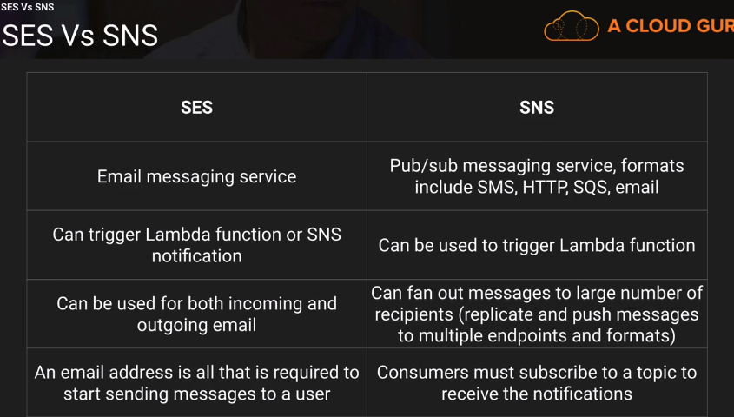

**This is not subscribe model Consumers has to subscribe**

**Kinesis**

**DEVELOPER THEORY**

**CI/CD**

**Tools in AWS**

**Codecoommit – repository**

**CodeBuild - Build Management System**

**CodeDeploy – Deploy the packaged application**

**CodePipeLine – End to end release process**

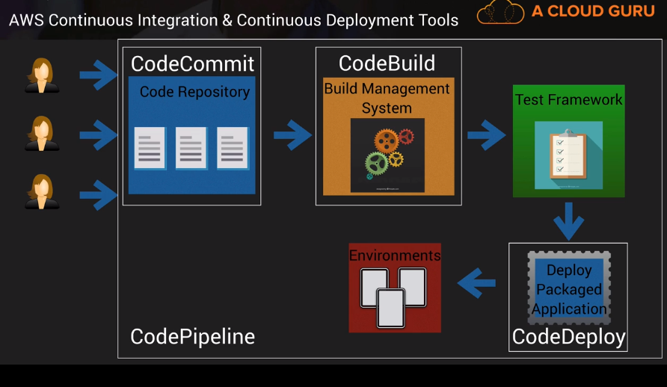

**CodeCommit**

**Fully managed code source control service that enables companies to host secure and highly scalable GIT repository.**

**You can use GIT on your local machine to interact with your code commit**

**Your data is encrypted in transit and at rest**

**Lab**

1. **Create a repository**
   1. **Gives option for HTTPS or SSH** You cannot configure SSH connections for a root account, and HTTPS connections for a root account are not recommended. Consider signing in as an IAM user and then setting up your connection.
2. **Everything is similar to git**
3. **You can configure SNS (for notification when PR is created, updated or closed) and cloud watch (for PR comment events)**

**CodeDeploy**

**Is an automated deployment service . you can deploy to EC2 instance, on-premis systems and lambda functions.**

**Automatically scales with infrastructures and also integrates with various CI/CD tools eg Jenkins, Github, Atlassian, AWS code pipeline. Integrates with config management tools like Ansible, puppet and chef**

**Two deployment approaches**

1. **In-place**

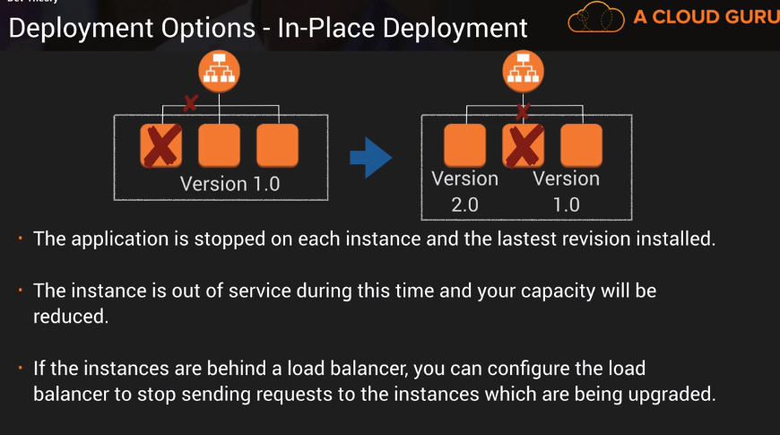

1. **Blue/Green \*\***

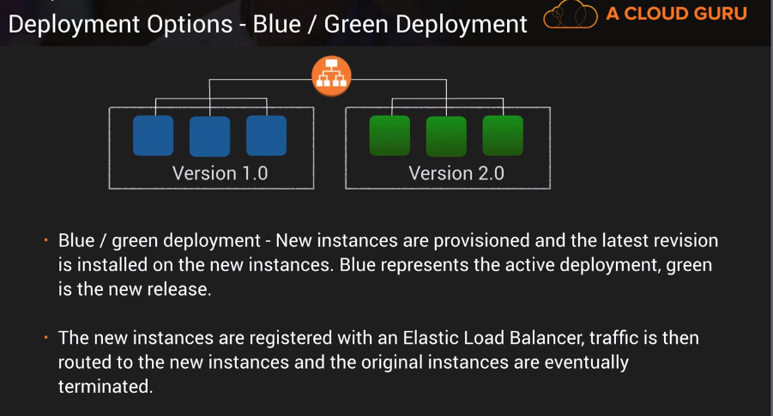

**Deployment terminology**

**Deployment Group : A set of EC2 instances or Lambda functions**

**Deployment configuration : A set of deployment rules as well as success/failure conditions used during a deployment**

**AppSpec file : Defines the deployment actions you want AWS code deploy to execute**

**Revision Everything need to deploy the new version: APpSPec file, application file, executables, config files**

**Application : unique identifier for the application you want to deploy. To ensure the correct combination of revision deployment configuratuin and deployment group are reference during a deployment.**

**CodeDeploy Lab**

**Create 2 roles**

**One for EC2 that talks to S3 from EC2 behalf of that role**

**One for CodeDeploy that talks to EC2 behalf of that role.**

**Then**

**#Install CodeDeploy agent on your EC2 instance:**

**sudo yum update**

**sudo yum install ruby**

**sudo yum install wget**

**cd /home/ec2-user**

**wget https://aws-codedeploy-us-east-2.s3.amazonaws.com/latest/install**

**chmod +x ./install // Installing codedeploy agent**

**sudo ./install auto**

**sudo service codedeploy-agent status**

**Here we need to configure awsconfig in our local machine to be able to deploy the code from our local machine to EC2 instance.**

**For that we need to create a IAM user with CodeDeploy full access and S3 full access**

**Open local command or terminal window**

**run**

**Aws configure**

**#Create your application.zip and load it into CodeDeploy:**

**aws deploy create-application --application-name mywebapp**

**aws deploy push --application-name mywebapp --s3-location s3://<MY_BUCKET_NAME>/webapp.zip --ignore-hidden-files**

**The above commands copies all the code files into S3**

**Then create deployment group and start deployment.**

**CodePipeline**

**CodePipeline is a fully managed CI and CD service**

**This can orchestrate the build test and even deployment of your application everytime there is a change to your code all based on a user defined software release process.**

**Manual approached to code delivery can be slow and prone to errors. So automation of this process all to frequent releases in fast and reliable manner**

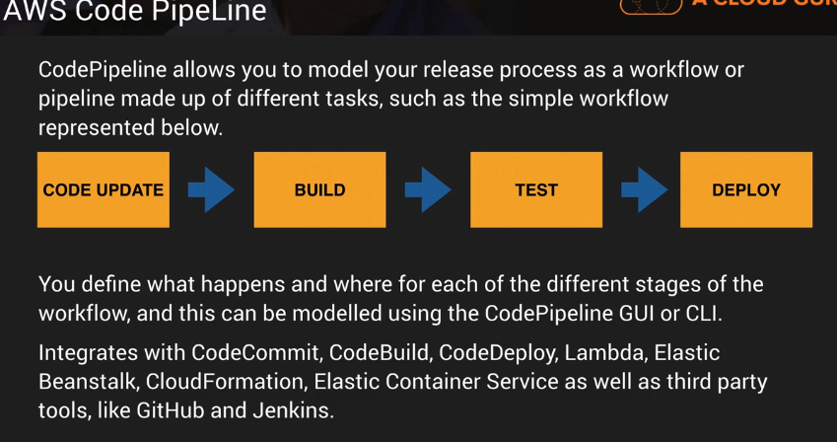

**The pipeline stops automatically if one of the stages fails. And any changes will be rolled back**

**When there is a change in code**

1. **S3 triggers alert Cloud watch for the change in source code.**
2. **CodePipeLine let Codedeloy to deploy the change**
3. **CodeDeploy go into S3 where Source code is**
4. **Deploys either to physical server, Ec2 instance or Lambda function**

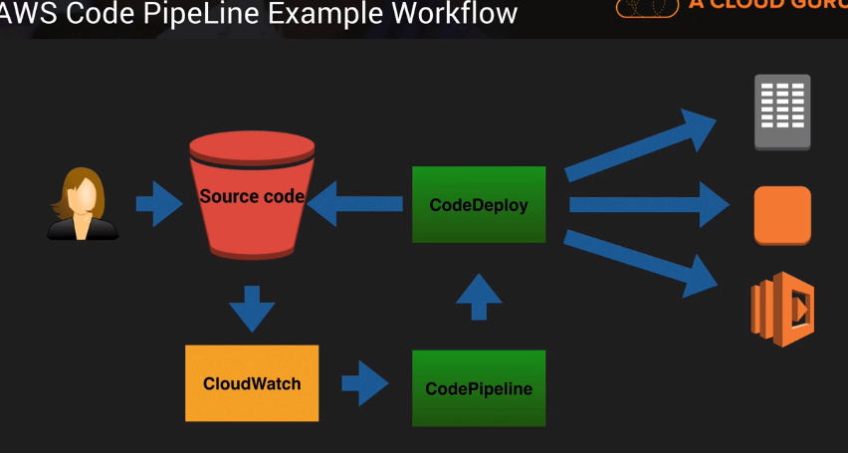

**CodePipeLine Lab**

**Launch EC2 instance using Cloud Formation template.**

**Create CodePipeline to point to S3 SourceCode folder.. So if there is a latest version it is going to deploy the code.**

**AppSpeFile**

**It is used to define the parameters todefine the parameters that will be used for a CodeDeploy deployment. The file structure depends on whether you are deploying to Lambda or EC2/On Premises.**

**For Lambda deployments , the AppSpec file may be written in YAML or JSON contain the following fields**

1. **version : Reserved for future use- currently the only allowed value is 0.0**
2. **resources : Te name and propertied of the lambda function to deploy**
3. **hooks : Specify Lambda functions to run at set point in the deployment lifecycle to validate the deployment . EX: validation tests to run before allowing traffic to be sent to your newly deployed instances.**
4. **BeforeAllowTraffic : used to specify the tasks or function you want to run before traffic is routed to the newly deployed Lambda functions**
5. **AfterAllowTraffic : After the lambda deployment**

**Example:** 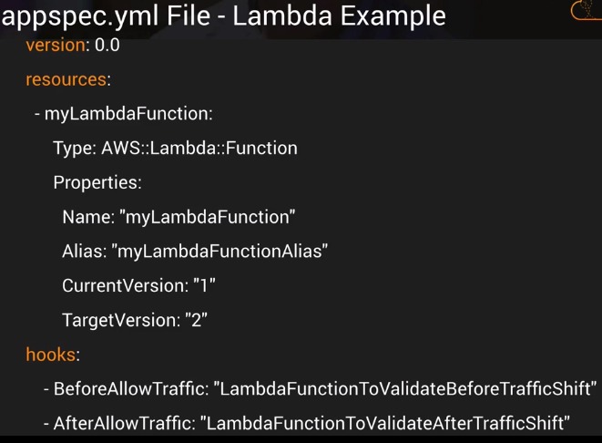

**For EC2 and on-premises , the appspec file is slight different**

1. **version:**
2. **os : The OS is used for EC2**
3. **files: The location of any application files need to be copied and where they should be copied to *source* and *destination* folder.**
4. **hooks: Lifecycle event hoos allow you to specify scripts that need to run at set points in the deployment life cycle (ex: to unzip application files prior to deployment, run functional tests on the newly deployed application, and to de-register and re register instances with a load balancer.)**

**For EC2 and On Premises deployments the appspec.yml should be placed in the root of the directory of your revision- this is the directory containing your application source code otherwise the deployment will fail.**

**Mywebapp folder :**

**Appspec.yml**

**/scripts**

**/config**

**/source**

**Hooks part of the appspec file is very important to understand. These tasks need to be run sequentially.**

**1st set of sequence**

1. **BeforeBlockTraffic: Run the tasks on instances before they are deregister from load balancer**
2. **BlockTraffic : Deregister instances from load balancer**
3. **AfterBlockTraffic: Run tasks on instances after they are deregister from load balancer.**

**2nd set of sequence**

1. **ApplicationStop**
2. **DownloadBudndle : copies the application revision to temp location**
3. **BeforeInstall : any pre installation steps**
4. **Install : install the application revision files from temp location to correct location**
5. **AfterInstall : any post installation scripts**
6. **ApplicationStart: Restarts any services that were stopped during installation**
7. **ValidateService : Details of any tests to validate the service.**

**3rd set of sequence**

1. **BeforeAllowTraffic**
2. **AllowTraffic**
3. **AfterAllowTraffic**

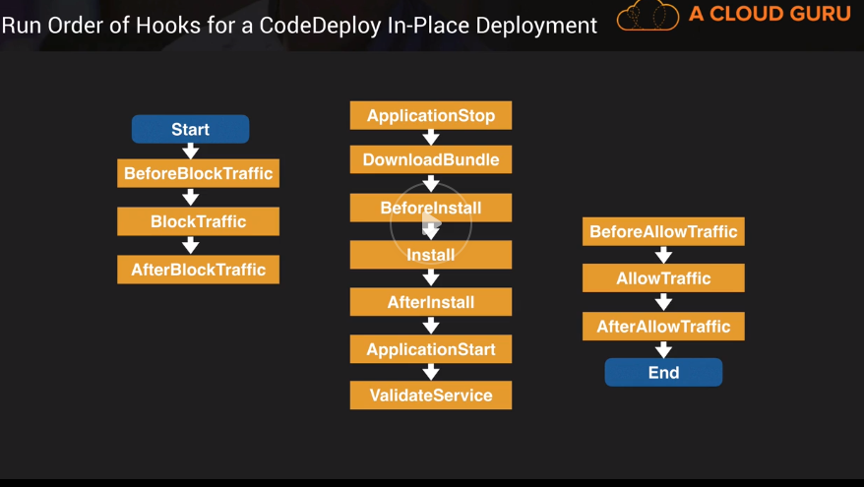

**Docker And CodeBuild**

**Docker is an open source technology which allows you to create applications based on either Linux or Windows containers**

**A container is a lightweight standalone executable software package which includes everything the software needs to run code, runtime environment, libraries, environment settings etc.**

**AWS provides Elastic Container service as a fully managed clustered platform which allows you to run your docker images in the cloud.**

**CodeBuild**

**AWS CodeBuild is a fully managed build service which runs a set of commands that you define, eg compiles code runs tests and produces artifacts that are ready to deploy.**

**LAB**

**CodeBuild takes the source code from codecommit and build Docker Image.**

Amazon Elastic Container Registry (Amazon ECR) is a managed AWS Docker registry service that is secure, scalable, and reliable. Amazon ECR supports private Docker repositories with resource-based permissions using AWS IAM so that specific users or Amazon EC2 instances can access repositories and images. Developers can use the Docker CLI to push, pull, and manage images.

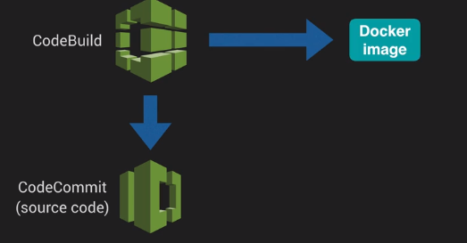

**Push commands to use docker images to repository (As per my understanding, these commands create docker image off of the elastic cluster and will push into the repository)**

**1**

**$(aws ecr get-login –no-include-email --region <regionname>) [This for Mac/Linux]**

**Invoke-Expression -Command (Get-ECRLoginCommand -Region <RegionName>) [This isfor windows]**

**2 (Build the docket image)**

**Docker build -t <mydockerrepo>**

**3(After the build, tag your image so you can push the image to the repository)**

**docker tag mydockerepo:latest 103881558228.dkr.ecr.us-east-2.amazonaws.com/mydockerepo:latest**

**4(To push this image to newly created AWS repository)**

**docker push 103881558228.dkr.ecr.us-east-2.amazonaws.com/mydockerepo:latest**

**Now create a task definition**

Task definitions specify the container information for your application, such as how many containers are part of your task, what resources they will use, how they are linked together, and which host ports they will use.

**Two types of task definition**

**Fargate**

**EC2**

**Then create a service to run the task definition**

**CodeBuild**

**Use Codebuild to automate all of the above work to create a docker image**

**It uses buildspecfile.yml to tell the codebuild how exactly to build docker image**

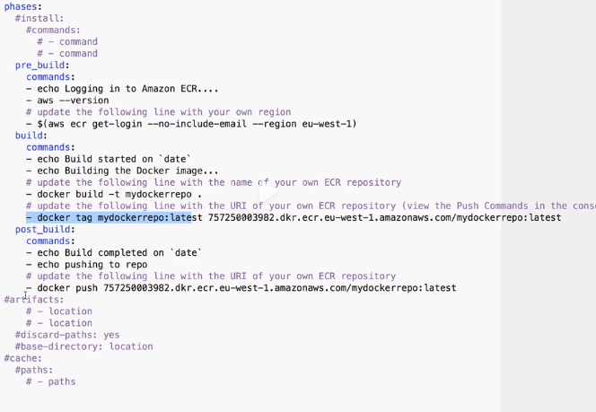

* **You can add these files to CodeBuild (from S3 or, Git)**
* **You can use the existing buildspecfile or insert the build commands while creating the codebuild project. (Important for the exam)**

**Exam tips**

**If your build fails , check the build logs in the CodeBuild console and you can view the full codebuild log in CloudWatch**

**CloudFormation**

1. **CloudFormation is a service that allows you to manage configure and provision your AWS infrastructure as code.**
2. **Resources are defined using CloudFormation template**
3. **CloudFormation interprets the template and makes the appropriate API calls to create the resources you have defined**
4. **Supports YAML or JSON.**
5. **It is consistent , less time and effort than configuring things manually**
6. **Free to use**
7. **You can do the version control and able to do peer review.**
8. **Can be used to rollback and delete entire stack**

**CloudFormation template**

1. **YAML or JSON can be used to describe the endstate of the infrastructure**
2. **After creating template you upload it to CloudFormation using S3**
3. **CloudFormation read the template and makes the API calls on your behalf**
4. **The resulting resources are called a stack.**

**YAML – Remember all these sections for exam**

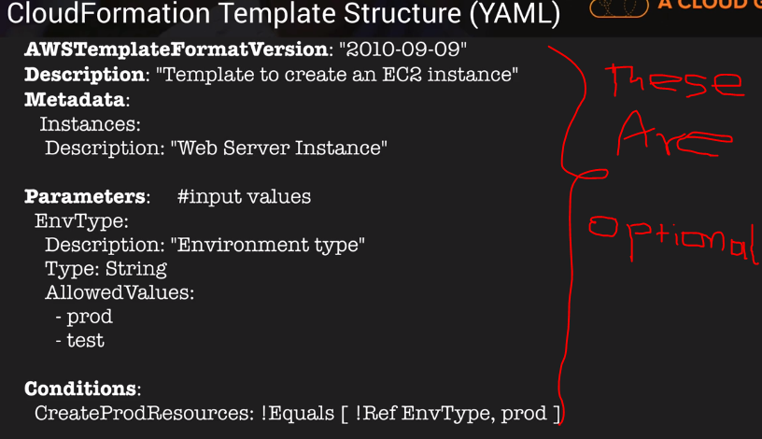

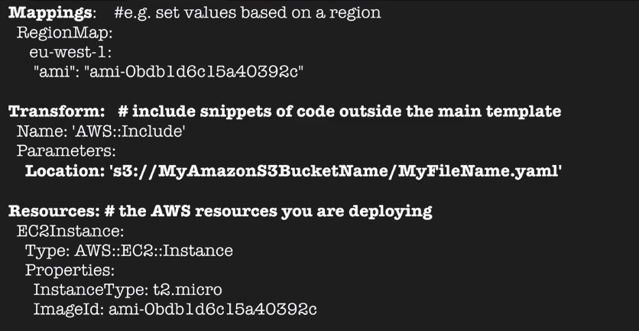

**Outputs:**

**InstanceID:**

**Description: The instance ID**

**Value: !Ref EC2Instance**

**Check AWS template snippets in AWS documentation for various resources.**

**Resources is the only mandatory section of the CloudFormation Template**

**\*Transform section is used reference additional Code stored in S3,allowinf for code re-use like using Lambda code or template snippets.**

**CloudFormation LAB**

**AMI is region specific**

**Create a stack. You can create from sample template, choose file from your local machine, choose from S3 bucket or you can use the designer for creating task.**

**You can have an option that if cloudformation fails you can rollback all the changes.**

**Serverless Application Model(SAM)**

**SAM is an extension to CloudFormation used to define serverless application.**

**Simplified Syntax for defining serverless resources: API s, Lambda functions, DynamoDB etc.**

**Use SAM CLI to package your deployment code, upload it to s3 and deploy your serverless application.**

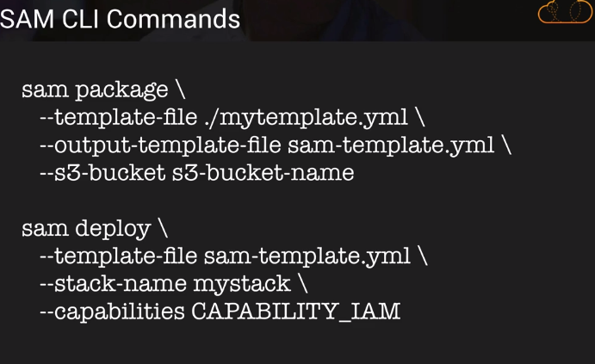

**The sam package command takes the yml file and convert to SAM compatible template and uploads to S3 bucket**

**The sam deploy command takes the sam template . specifies the name of stack and then enables to create an IAM role – deploys your serverless app using CloudFormation**

**Lab**

**Deploying Lambda function**

1. **Install the SAM CLI based on your OS**
   1. **Install homebrew**
   2. **Then install sam cli**
2. **Create S3 bucket to use uploading Lambda functions.**
3. **Upload lambda function and CloudFormation templates**
4. **Use *sam package* and *sam deploy* commands to create the stack**

**CloudFormation Nested Stacks**

**Nested stacks allows re-use of CloudFormation code for common use cases.**

**Eg. Standard configuration for a load balancer, web server, application server etc.**

**Instead of copying the code each time, create a standard template for each common use case and reference from within your CloudFormation template.**

**Basically template within template**

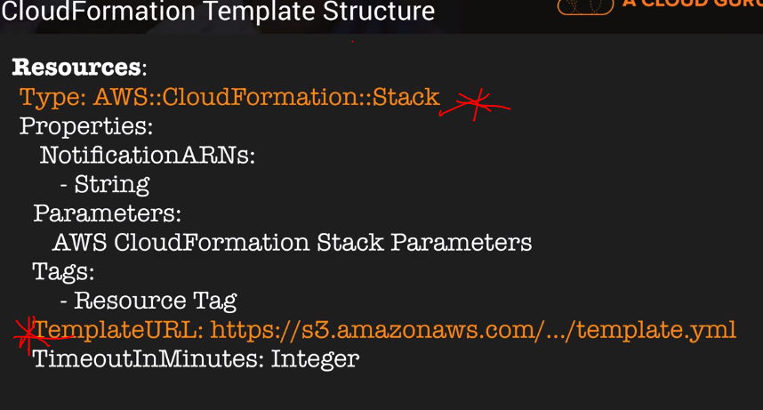

**Action Items**

1. **Read more on DynamoDB indexes**
2. **Memorize EC2 instance types**
3. **S3 FAQs**
4. **Read whitepaper about CI CD practicing integration continuous delivery**
5. reading S3, Dynamo, CloudFormation, Elastic Beanstalk, VPC tutorial from AWS website.
6. The AWS documentation states that; "You can think of a file gateway as a file system mount on S3." **Amazon** **Elastic File System** (EFS) is a mountable file storage service for EC2, but has no connection to S3 which is an object storage service. Amazon Elastic Block Store (EBS) is a block level storage service for use with Amazon EC2 and again has no connection to S3
7. Elastic Beanstalk is free to use, just like CloudFormation. You only pay for the resources which are deployed as part of it – I am not failed
8. What is the maximum long poll time out – 20 seconds
9. what is VPC
10. 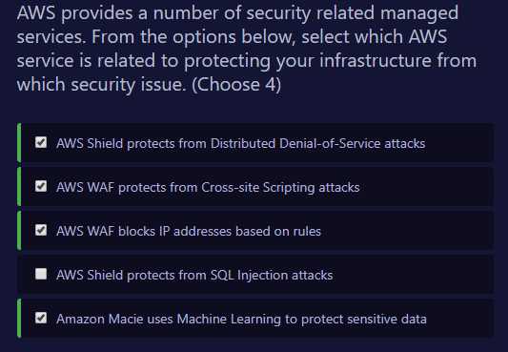

**QUESTIONS**

**How do you migrate existing SQL DB to RDS or DynamoDB?**

**Where do you set caching mechanism either MemCached or Redis Cache.**

**Migrate Dotnet code indeed any code to AWS.**

**What are symmetric and asymetrickeys in KMS?**

**Commands**

**Sudo su**

**Echo “some text” > sometestfile.txt**

**Ls list folder**

**Nano open the file**

**Curl to call api**

**Cat open a file**

**wQ! Save**